**Tableau**

Tableau is a data visualization, exploration, and analysis tool. It allows you to visualize your data in new and varied ways that enhance your analysis. Sometimes, it tends to bring out the kid in you, making you excited and giddy about the pending eureka moments. You can *see* it (pun intended)!

Tableau allows you to connect and mash up your data to see it in different forms and possibilities, such as overlaying weather data onto sales data, or Twitter feed trends combined with survey data. This helps you understand your data, uncover insights, or at least helps you ask the next questions.

This section provides a brief introduction to Tableau and is not meant to be an exhaustive resource on the ins and outs of Tableau. There is so much more about Tableau than what is covered here, but this document should help you get a head start with Tableau if you haven't worked with it before. And if you already have, this should provide a good refresher.

# Notes from the field

Before we dive into the primer, I'd like to offer you perhaps a personal, and maybe a not-soconventional way to introduce Tableau. I'd like to highlight a few key concepts and tricks that I think will be useful to you as you go along. These are certainly points I highlight on the board whenever I do training on Tableau. If you feel like we are jumping too far ahead, please go ahead and start with the *Tableau primer* section first and come back to this section when you are ready for the tips and tricks.

Instead of thinking of Tableau as this software tool that has a steep learning curve, think of it as an artist's canvas—your canvas awaiting your creation. You will draw on it, keep on adding things and removing things until something makes sense or something insightful pops out. After you work with Tableau for a while and get more comfortable with its functionalities, it might even feel like an extension of your brain to some degree. When you get access to data, you might automatically open Tableau to try and understand what's in that data.

## Undo is your best friend

Do not be afraid to make mistakes, and do not be afraid to explore in Tableau. Do not come in with strict prejudice, for example, thinking that you can only use a time series graph when you have a measure and a date field. The best way to learn and explore how powerful Tableau is to try anything and everything. It's one of the best tools to experiment with your data.



If you make a mistake, or if you don't like what you see, no sweat. Just click on this friendly undo button and you are back to your previous view. If you are more of a shortcut person, it will be *Ctrl* + *Z* on a PC or *Command* + *Z* on a Mac.

## It doesn't change your original data

This is another common concern that comes up in my training sessions or whenever I talk to people about Tableau. No, Tableau does not write back to your data source. All the changes you make will be stored in Tableau, such as creating calculated fields, changing data types, and editing aliases, will be stored in your workbook or data source.

## Drag and drop

Tableau is a highly drag and drop tool. Although you can use the menu or right-click instead of a drag and drop for the same tasks, dragging and dropping is often faster. It also flows with your train of thought.

## Look for visual cues

Tableau leverages its visual culture in your design area, so when you create views in Tableau, some of the visual cues and icons can help you along the way. A number of the visual cues have been discussed in the next section. However, there may be some lesser known (or less noticeable) visual cues:

* Italicized field names mean they are Tableau-generated fields:

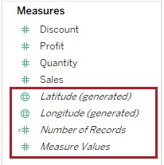

* Dual axis charts create fused pills. Notice the area when the two pills touch—they're straight instead of curved:

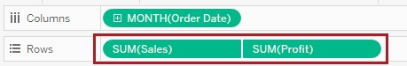

* When you zoom in to maps, or when you search for a place, your map gets pinned (or fixed to this place) until you unpin it:

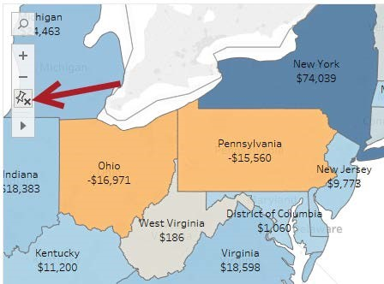

|  |  |
| --- | --- |
| **Know the difference between blue (discrete) and** | |
| **green (continuous)** |  |

Knowing the difference between blue and green will take you far in the Tableau world. The data type icons you will find beside your field names in the side bar are colored either blue or green. When you drag fields onto shelves and cards, the pills are also colored blue and green.

Simply speaking, blue means discrete and green means continuous. Discrete means individual, separate, countable, and finite. Continuous means a range or continuum, and technically, there is an infinite number of values within this range.

What's more important is how these manifest in Tableau. A blue discrete field will produce a header, and a green continuous field will produce an axis. If dropped onto the Color property in the Marks card, for example, a blue discrete field will use individual, finite colors. A green continuous field will use a range (gradient) of colors.

Some confusion also usually arises when we see that, by default, Tableau places numeric fields under Measures and are colored green, and categorical information under Dimensions are colored blue. This won't always be the case. We can have numeric values that are discrete, for example, an Order Number. We can also see non-numerical, discrete fields under Measures.

## Learn a few key shortcuts

Shortcuts are great. When you know a few of them by heart, you'll work faster.

Here are some of my favorite shortcuts:

|  |  |
| --- | --- |
| Shortcut | What it does |
| Right-click + drag | Opens the Drop Field menu (also called Quick Field Property Selection window), which allows you to specify exactly which variation of the field you want to use. |
| Double-click | Adds the field to the view.  I particularly like this when creating text tables. After you place your first measure in text, you can add more measures to your text table by doubleclicking on the succeeding measures. |
| Ctrl + Arrow | Adjusts the height/width of the rows/columns in the view. |
| Ctrl + H | Presentation mode. |

You can find the complete list of shortcuts here: [**http://bit.ly/tableau-shortcuts**](http://bit.ly/tableau-shortcuts)

## Unpackage option

The **.twbx** file is a Tableau packaged workbook, which means it packages local files with your Tableau workbook. When you right-click a **.twbx** file in a machine that has Tableau Desktop installed in it, you will see a new option called *Unpackage*:

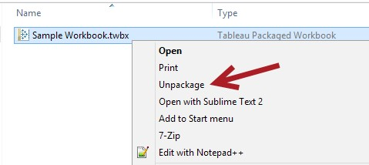

When you unpackage a **.twbx** file, you will get the **.twb** file and another folder that contains all the local files that were used in the original workbook:

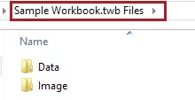

Just keep in mind that data (at least the file-based data sources and extracts) get packaged with your **.twbx** files. This is an important security and data governance consideration when you are deciding how to share your workbooks with others.

## Your sidebar didn't disappear

My first class in Tableau always includes this exercise.

I ask the students to click on the following arrow:

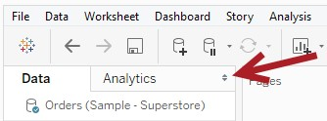

Then I ask them to bring it back up (without having to restart their Tableau instance, of course).

I think it's important to know how to minimize and maximize the side bar instead of assuming it will always be there.

By the way, to bring it back, you can do either of these things: f Go to the Window menu and select Show Side Bar:

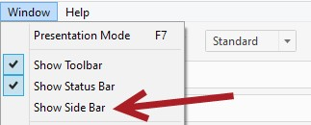

f Click on the arrow minimized Data window at the left side of the status bar – in the bottom-left corner of the Tableau Desktop window:

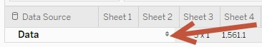

While this exercise may seem trivial, my hope is that this saves them both time and stress in the long run. (It would be very stressful to work on a deadline and not find the side bar and not know how to get it back!)

## It is possible…

Another common question that comes up is *can I do <this>?* or *is it possible to do <this>?*.

The answer to many of the questions is yes, and many will include calculations, parameters, and a few other tricks. While many are possible, not all solutions will be quick and straightforward. Some may require multiple calculated fields, table calculations, LOD expressions, regular expressions, R scripts, and so on.

## Table calculations are calculations on your table

How you structure or lay out your table (or view), by default, will affect your table calculations. Table calculations are highly influenced by the following things:

* Layout. f Filters. f Scope and direction:

Let's say, for example, you are calculating the percent of total in your view.

* If you swap the fields in your Rows and Columns, that is, changing the layout, your numbers will change.
* If you filter some of the products out, your numbers will change.
* If you decide to compute Pane Down instead of Table Across, your numbers will change.

There are ways to fix table calculations so they are not affected by layout. These can be done when you edit the table calculations and manually adjust the addressing and partitioning fields, which is beyond the scope of this primer.

If you're looking for the common use cases for table calculations, check out the Tableau article entitled *Top 10 Tableau Table Calculations*, which can be found here: [**http://bit.ly/top10tablecalcs**](http://bit.ly/top10tablecalcs)

## LODs rock

Many of the tasks that required complex table calculations or data blending have been greatly simplified by LODs (Level of Detail expressions). LODs allow us to have multiple levels of detail within a single view, for example, showing the average per region, average per state, and average per zip code all in the same view. It can also allow us to work with aggregations of aggregates, such as the average of an average or the median of an average. Before LODs, we needed to be really creative with Tableau, or pass this kind of computation to the data source altogether.

LODs have been improved in Tableau 10, now allowing expressions to be specified under dimension declarations.

To learn more about LODs, I encourage you to check out the following:

fUnderstanding Level of Detail Expressions [**http://bit.ly/UnderstandingLOD**](http://bit.ly/UnderstandingLOD) fTop 15 LOD Expressions [**http://bit.ly/top15LOD**](http://bit.ly/top15LOD)

There is also another chapter in this book, *Appendix B*, *Calculated Fields Primer*, that discusses LODs in more detail.

# Tableau primer

I'd like to take you on a whirlwind tour on how you can start working with Tableau from the ground up.

When you install Tableau, there will be a folder called My Tableau Repository that gets installed in your machine that by default. It hosts files related to Tableau:

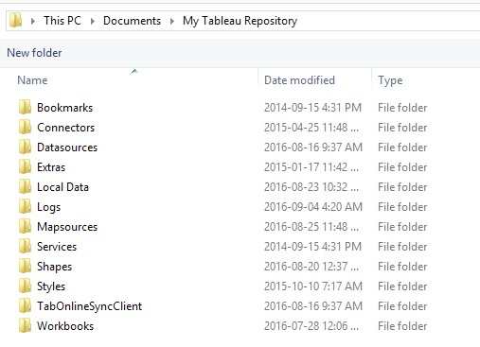

## Lingo

Before we get started diving deeper into the interface, here is some terminology that you might hear or encounter when you work with Tableau. Let's define them upfront so they do not cause confusion as you read through the rest of the chapter:

|  |  |
| --- | --- |
| Lingo | Meaning |
| Viz | Short for visualization. |
| View | Worksheet, graph, or chart. |

|  |  |
| --- | --- |
| Lingo | Meaning |
| Pill | What data fields are called in Tableau.  They are called this because they look like (medicine) pills you drink. |
| Shelves | Places where you can put your pills |

### Tableau splash screen

When you first open up Tableau, you will see the initial screen that is divided into three main columns. The left column lists different ways to connect to data sources – either file-based, server-based, or using a saved data source. The center column shows thumbnails of the most-recently opened workbooks, as well as sample dashboards that come out-of-the-box.

In the right column, you will find links to training, blog posts, and the *Viz of the Week* feature:

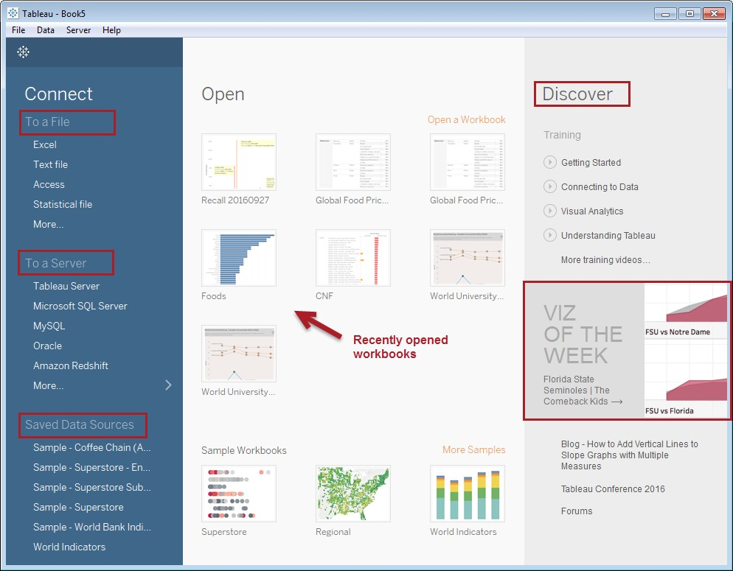

Tableau boasts a rich set of server-based data source connections baked into the product. You can connect to file-based data sources such as Excel, text files, Access, and statistical files (SPSS, SAS and R). You can also connect to server-based data sources:

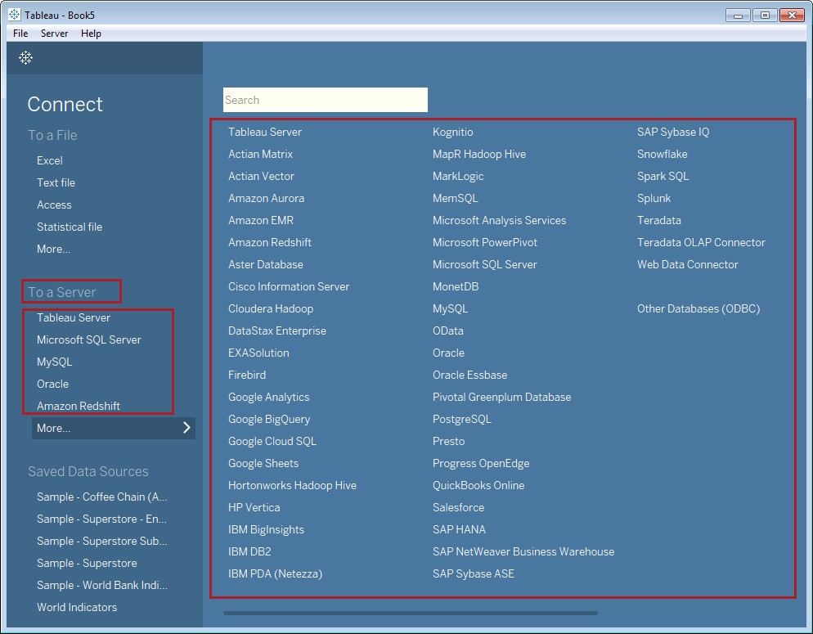

If you don't see your data source here, there is still a good chance that you can connect to your server data source using ODBC (Open Database Connectivity). You will just need to get the appropriate driver from your data source vendor or provider.

In future releases, Tableau promises to add native connectivity to JSON files and shape (**.shp**) files:

[**http://www.tableau.com/coming-soon**](http://www.tableau.com/coming-soon)

### Initial connection screen

When you connect to your data source, you will see all the table-like objects on the left-hand side. The title you see will depend on the data source you connected to. If you connect to Excel files, you will see Sheets. If you connect to relational databases, you will see tables, views, stored procedures—whichever objects are supported for that data source:

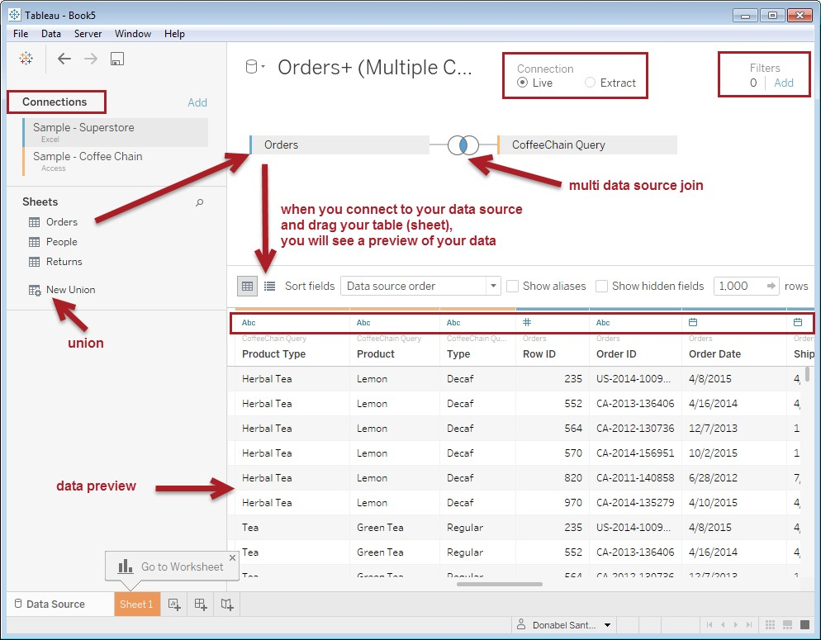

The preceding screenshot shows that when you drag a sheet from the left pane to the central connection area where it says *Drag Sheets Here*, you will see a preview of the records in the bottom grid. Along with the preview of the data, you will see some visual cues about your data. Above the column names, you will see icons that represent what Tableau assumes the data type is based on the first few records.

When you click on the dropdown beside a data source that you dragged onto the canvas, you will additional options that help you shape or clean up your data. Depending on the data source, you may see slightly different menu items. The following screenshot shows what you will see when you connect to an Excel file—with an option to specify that field names are in the first row or to generate them automatically:

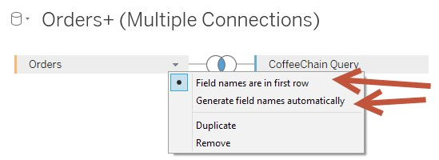

If you are working with a text file, you will have additional options to specify the text file properties, such field separator, text qualifier, character set, and so on:

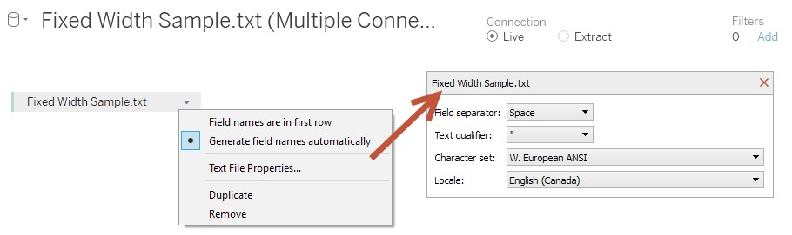

#### Connection types

In the top-right corner there is a Connection option to use either Live or Extract:

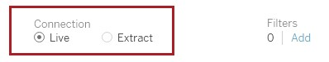

A Live connection has a direct link to the data source. Whenever the data (or even the structure) changes, it will be reflected in Tableau. Sometimes the changes are not immediately available and may require that you right-click on the data source and select Refresh:

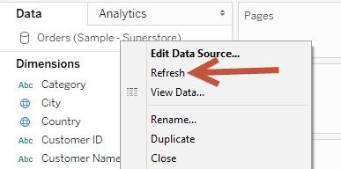

An Extract is, as the name implies, extracted data. When you extract data, Tableau pulls information from your data source and stores it locally in an optimized format and usually with a much smaller footprint. Note that you may not be able to extract data from some data sources, such as a cube.

When you select Extract, by default all data will be included. You can edit this and be more selective on what will be included. There are options to add filters, exclude unused fields, or to roll up data and only keep aggregated data in the extract:

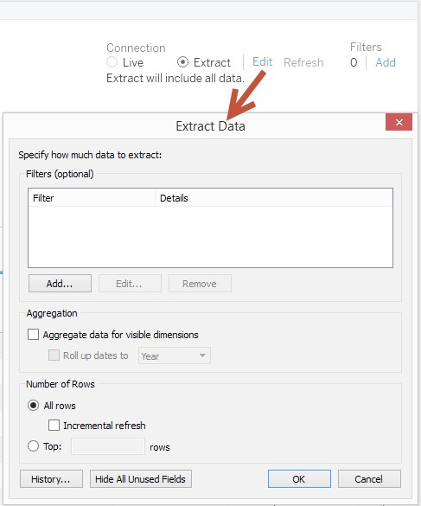

The option to create an extract is also available in the worksheet design view:

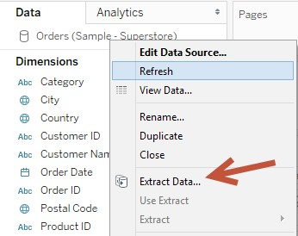

Once you create a data extract, the icon of the data source in the worksheet view becomes two cylinders with an arrow. This is representative of the fact that an extract becomes a *shadow database*:



Because the extract is optimized and often much smaller in size compared to the original data set, the extract is much easier to load into your computer's memory, which results in much faster visualizations. Needless to say, one of the reasons for using extracted data is performance.

Another reason for using extracts is portability. Because the data is local and optimized, it can be packaged with your workbook when you save .*twbx* files. Whoever needs to use your workbook will not need to know or be able to connect to the original data source.

There are a few other reasons for going the extract route. However, these reasons may very well be double-edged swords: f Performance would be great for smaller data sets, but if you extract quite a big data set and run it on a machine with limited resources, you may see performance become worse. There are cases where it's faster to use live data connection, especially if the data source is hosted on a very fast, powerful server. f Portability is great; however, we also need to keep in mind that as we share these packages, we are also sending underlying data. We need to be aware of what our data governance guidelines allow us to share or not share (whether in detailed or aggregated format). f Another potential issue with extracts is the proliferation of outdated data. If we had shared multiple versions of extracts, or an extract of an extract of an extract, it may become a manageability nightmare to track all these down and update each version accordingly.

Whether using Live or Extract, it is important to know the advantages and limitations of each type of connection to help us decide which connection is right for our needs.

If you want to learn more about live and extract connections, Tableau has an article called *Tableau Online Tips: Extracts, Live Connections, & Cloud Data*

which can be found at [**http://bit.ly/tableau-connections**](http://bit.ly/tableau-connections)

#### Data Source and Extract filters

Data that flows through to Tableau can be filtered when you connect to the data source. One of the biggest reasons to filter at the data source level is performance. If you don't need to pull all the data, don't. When we narrow down the data that flows through to Tableau, Tableau can operate faster.

We can add the filter regardless of our connection. Here is the filter screen for a live data connection:

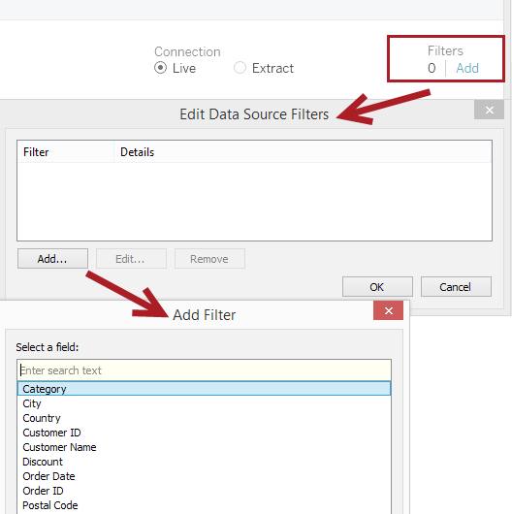

If you are connecting via an extract, you will be presented a slightly different screen. Within the extract window, you can specify field conditions that will narrow down the data you pull into the extract. You are also provided options to aggregate data in the extract instead of pulling all the details. To make the extract size even smaller, you can choose to only pull a number of fields (for example, the top 100) or hide unused fields in the view:

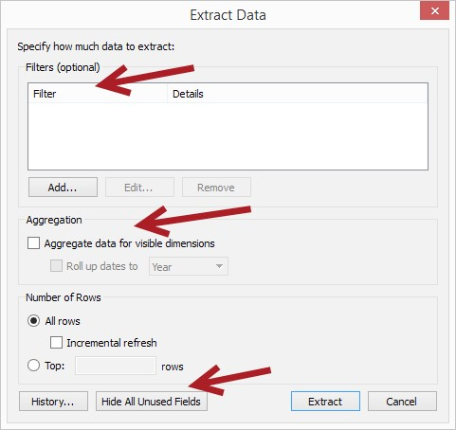

#### Data preview

Once you connect to Tableau, you will see a preview of your data in the connection screen. Unless you are using a data source that has metadata about the fields defined, the metadata and visual cues you see are Tableau's best guess based on the first few records that are read:

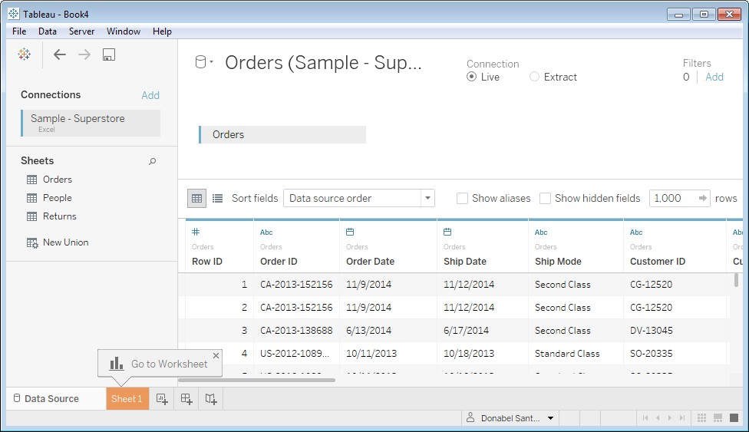

If, for example, the data type is incorrect, you can make the necessary adjustments from within Tableau. And no, it does not write the changes back to your data source.

#### Metadata view

From this screen, you can change some of the properties. You can also switch to the metadata view to see a concise list of fields and data types, without seeing the sample data:

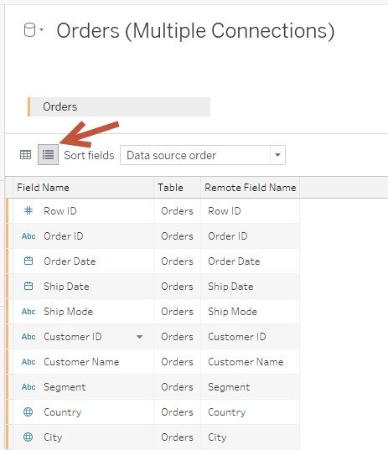

You can adjust your field settings from here, such as renaming fields, changing the data types, or creating calculated fields:

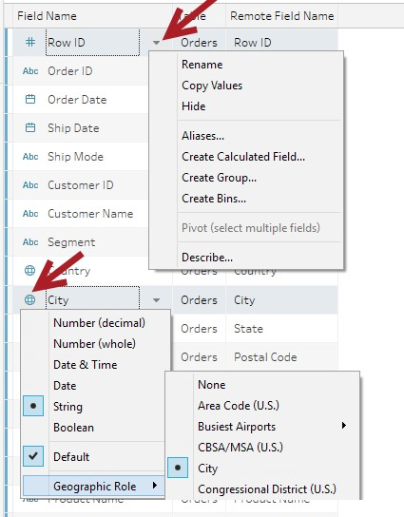

These same options are available in the worksheet view when these fields are presented in the data side bar.

### Worksheet design interface

When you click on the New Worksheet icon, or simply go to the Worksheet view, you will see the design area. This is where you will create and design your graphs. This area is also sometimes referred to as canvas. I find this very fitting as this is where you will make your drawing.

The following screenshot shows an empty canvas with some of the areas/components identified:

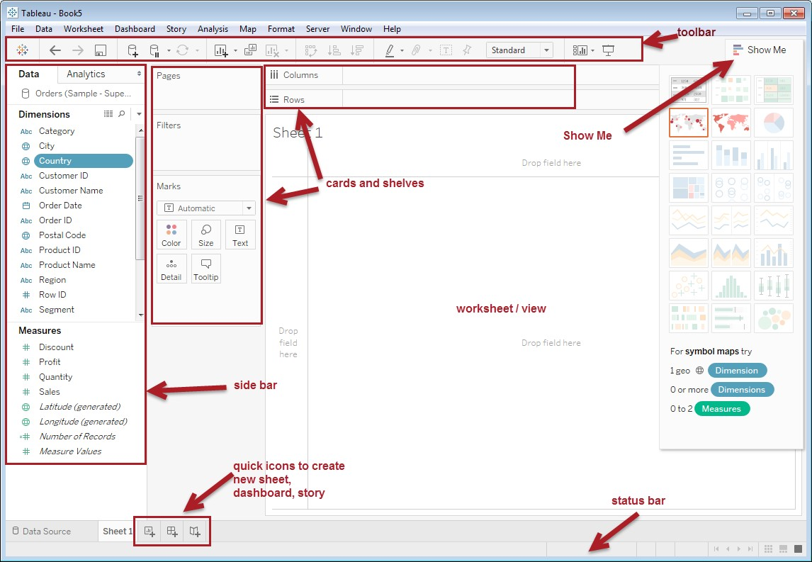

Brief descriptions of specific sections are as follows:

* The toolbar at the top of the screen hosts a series of icons that provide shortcuts to common tasks in Tableau, such as undo, add a new data source, and so on
* The sidebar shows your data fields under the Data tab, and analytics components under the Analytics tab
* The cards and shelves are where you can place your data fields f Show Me is like a graph wizard that shows you possible graphs based on fields you select
* The worksheet area (or view) is where your graphs will be displayed f The status bar at the bottom of the screen shows additional information about the view you are working on
* The quick icons at the bottom of the screen allow for three main Tableau components to be created, worksheet, dashboard, and story:

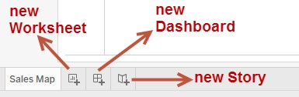

Once we build our graph (or view), we will see some additional components presented in our canvas:

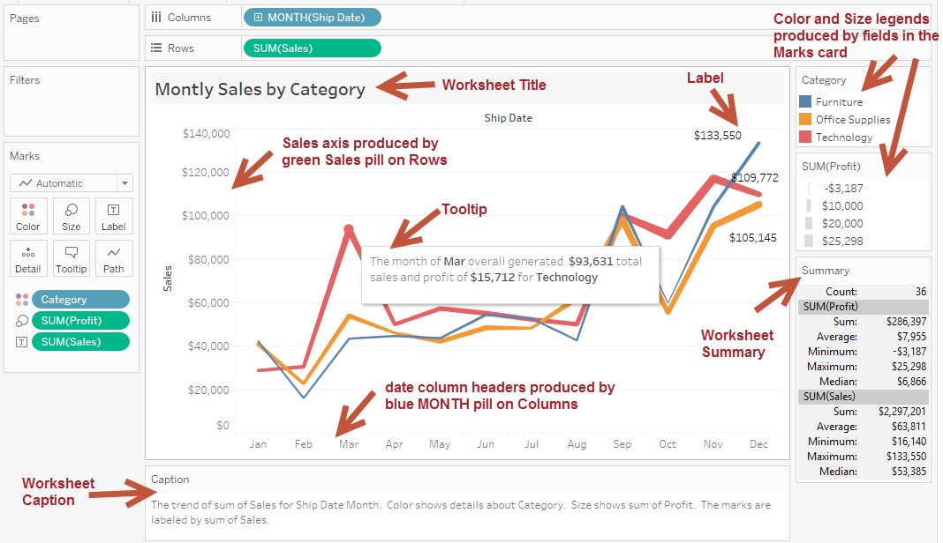

To describe the components of a sheet, we can go to the Worksheet menu and select Describe Sheet to get additional description regarding the worksheet, including what mark is used, what fields are used in different shelves, and so on:

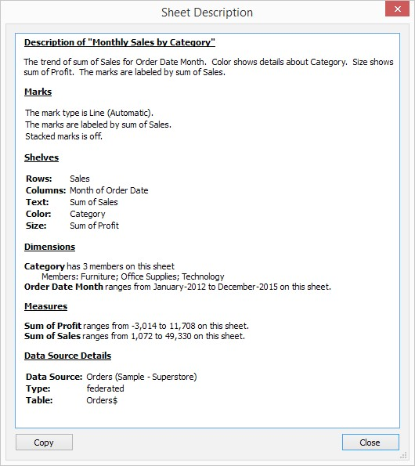

We can also get some quick statistics about our view by going to the Worksheet menu and selecting Show Summary, or by right-clicking an empty space in the Tableau workspace and selecting Show Summary. This will show a Summary box with some key numbers, such as Count, Sum, Average, Minimum, Maximum, and Median:

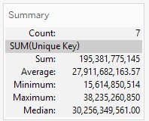

Many of these sections will be described in more detail in later sections.

### Side bar – simplified

The side bar is the pane on the left side that appears when you are in the worksheet design area. It contains the data from your data source, sets, parameters, as well as some Analytics components.

### Card and shelves

As you drag a field into the canvas to your worksheet, you will see several areas lighted up—or outlined with an orange border. These areas are called cards and shelves, and are the areas (or containers) where you can place your data field. Where we place the data field will affect what the visualization looks like, or what information is included in the visualization:

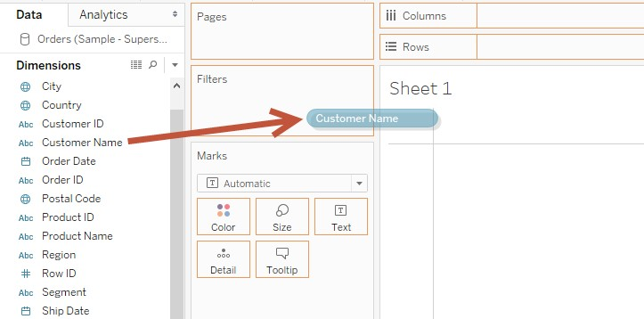

All these cards and shelves are further described in the next sections.

You choose to show, hide, or reset the cards from the Worksheet menu:

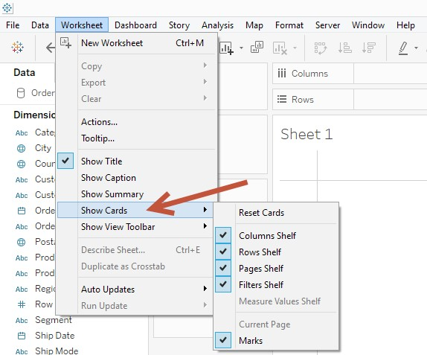

This can also be done from the toolbar:

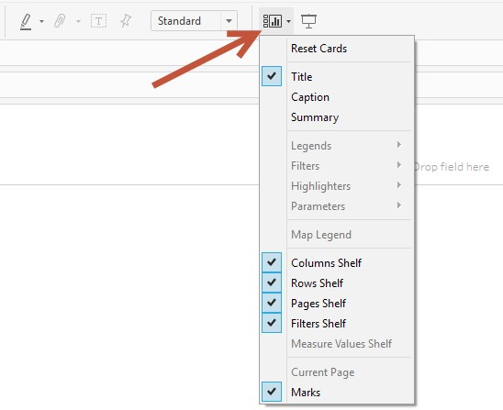

## Marks

Marks are what's drawn on your worksheet. When you simply add a field to your worksheet, Tableau will automatically decide what the best visual representation is based on the data types. In the Marks card, this will be identified with an Automatic mark, and an icon of the mark that was chosen:

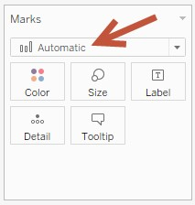

Tableau supports different mark types—including Bar, Line, Area, Square, Circle, Shapes, Pie, and Gantt. The complete list of options is shown in the following screenshot:

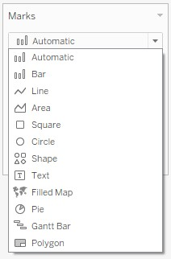

The Marks card also contain additional properties where you can place your pills – Color, Size, Label, Detail, and Tooltip:

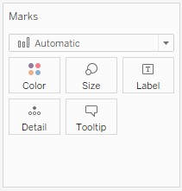

When you place your pills in the Marks card, the appropriate icons are placed beside the pill to allow easy identification of how these fields affect the view:

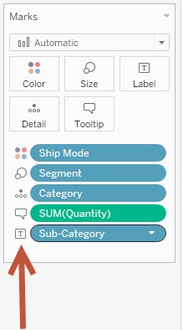

### Color

Color affects the color of the marks. You can manually assign colors from this card, or place a pill that will determine color distribution. When you click on Color, you will find additional options for Transparency, Border, and Halo:

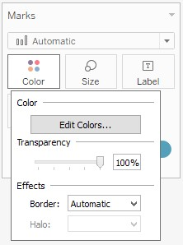

When you place a discrete field in the Color property in the Marks card, you will get discrete colors (one color per value in the field). When you place a continuous field, you will typically get a gradient of values. When you place a field in the color property, a corresponding color legend will be available.

The color legend card can be further customized when you click on the dropdown in the topright corner of the card. From here, you can edit the color to change the palette, format the legend, adjust the title, or sort:

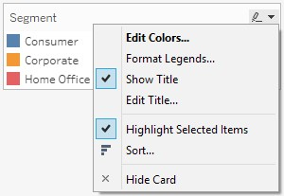

Beside the drop-down arrow of the color legend is a highlighter icon. This icon is a toggle, meaning it turns the feature on or off. When it is on, clicking on any of the values in the color legend will highlight that mark in the view, while all other marks will be dimmed.

Tableau 10 introduces the data highlighter. When you right-click on the pill on the Color property in the Marks card, you will see the option Show Highlighter. This adds a search bar that allows us to navigate values while seeing those values highlighted as we hover:

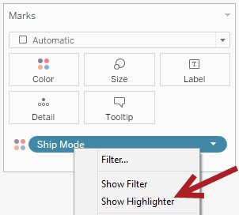

When you drag a field to Color when there is already a field there, it will, by default, replace the original pill. It is possible to layer colors by using multiple discrete fields in Color:

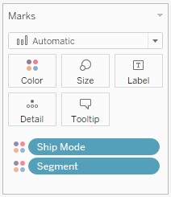

You can use either of the following techniques to do this:

f Press the Shift key while dragging the second pill to Color f Place the second pill to Detail first, then click on the Detail icon beside the pill and change to Color

These techniques work on discrete fields only. Continuous fields will always replace the previous color.

### Size

The Size property in the Marks card affects the size of the marks. When you click on this property, you will be presented a slider that increases or decreases the marks' sizes. When there are no pills in this property, adjusting the size affects all the marks uniformly. When there is already a pill on this property, adjusting the size will affect the marks proportionally based on the value of the pill.

Tableau 10 introduced continuous axes, which allows variable-width bar charts:

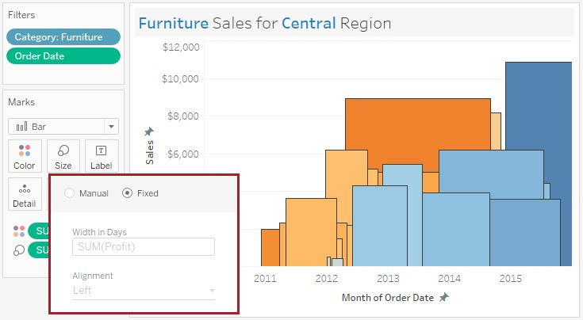

This new feature requires a continuous axis and the Bar mark type.

### Label

Labels are the text that get displayed with the marks. When you click on the Label property in the Marks card, you will see additional options that allow you to control the text that will be displayed. This also allows to specify if Labels should all be shown right away, or only on select/highlight, or perhaps only show it for the minimum and maximum values:

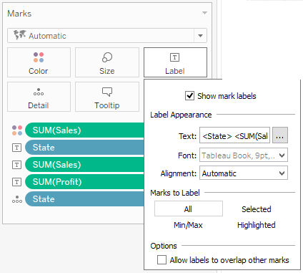

Depending on the mark type, you will see slightly different options available for Label. For example, if you are using the Line mark type, there will be options to label Line Ends and Most Recent.

Note that it is possible to show labels from the toolbar as well by using the Show Marks icon:



This, however, displays values based on what is in the view, and does not allow further tweaking or adjustments when it comes to format and other pieces of information you might want to include.

When you click on the ellipsis beside Text, you can adjust the format and even the text that will be shown. It's a typical text editor that allows you to change font, size, and so on. There is also a drop-down button called Insert that allows you to insert fields that were used in the view:

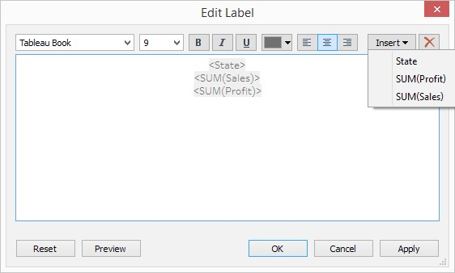

While you can override and allow labels to overlap, it may be best to leave this checkbox unchecked. In the following screenshot, you will see many overlapping labels that make the view really messy, unreadable, and unpresentable:

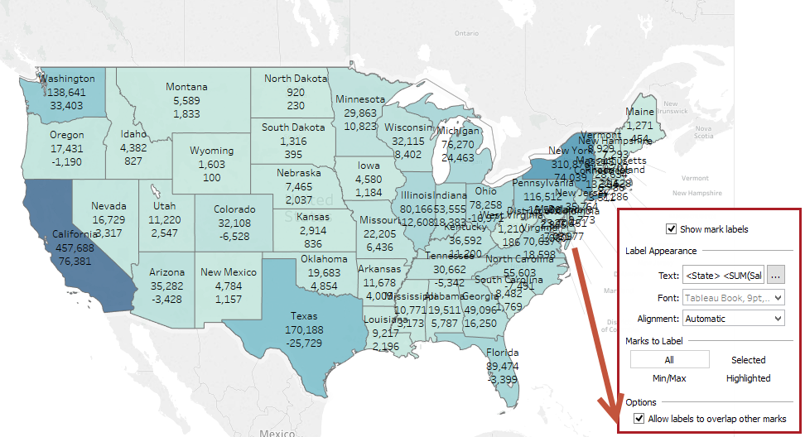

Little known fact: you can drag the labels to relocate them. When you select a mark and put your mouse pointer over the label, the mouse pointer icon changes into a crosshair with arrows (also called a move cursor):

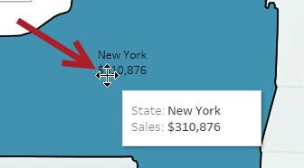

### Tooltip

When you hover over marks, the tooltip is the text that shows up. By default, with a small delay, the command bar also shows up. The command bar allows you to send additional requests to Tableau, such as excluding certain data or viewing underlying data:

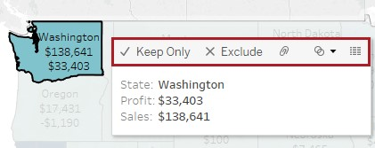

By default, all the fields you used in the view will automatically in the tooltip, and the tooltip by default shows.

When you click on the Tooltip card, a text editor window will show up that will allow tooltips to be modified and/or reformatted. You can also choose to show the command buttons or hide them, as well as show the tooltips or suppress them altogether:

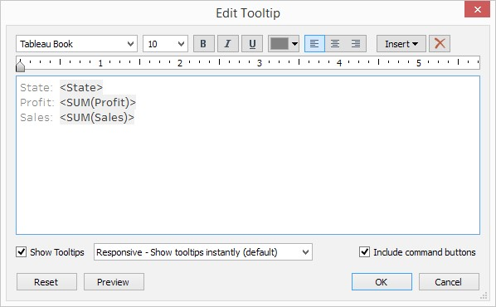

Take advantage of the tooltip to tell your data story, or to explain some points in more understandable lingo. Format your tooltips appropriately so it feels more intentional, rather than accidental or mechanical.

### Detail

There are cases when you want to include information but don't necessarily want it displayed as a mark or affect the mark display, for example, if you wanted to use a reference line that pulls the value from a data field, but don't want to use that data field in your view. You can use the Detail property in the Marks card for that. Fields you add in the Detail property in the Marks card will be available in the Insert dropdown found in many text editors:

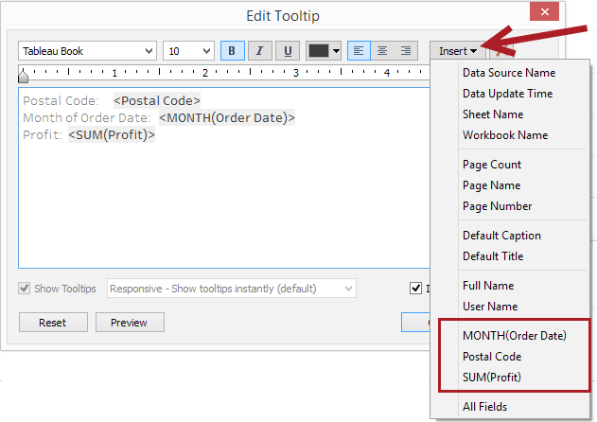

### Additional shelves

Depending on the mark type you choose, you may get some additional shelves in the Marks card. Here is a list of the extra shelves based on the mark:

|  |  |
| --- | --- |
| Mark | Extra Shelf |
| Line | Path |
| Pie | Angle |
| Shape | Shape |
| Polygon | Path |

## Pages shelf

The Pages shelf creates pages, or different versions of the current view based on the value of the field in the Pages shelf. The field you place in this shelf will automatically be converted into a discrete field, if it wasn't already.

The purpose of the Pages shelf is twofold:

f For animation f For printing Have you ever doodled on the corner of your notebook and started flipping the pages to see your stick figure come alive? The Pages shelf does exactly that. It flips through the pages, and allows the graph you've created to come alive.

When you place a field in the Pages shelf, you will see a play control that will allow you to determine play speed, as well as options to show the history:

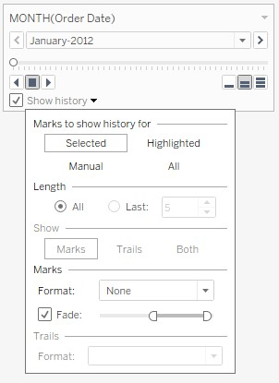

It is important to note, however, that this worksheet will lose the animation capability when published to server. You will still get the slider on the server; however, there will be no play control. The rationale for this is that Tableau does not want have a large footprint on the server, and does not want to have any dependencies on other plugins. The animation effect can be recreated, albeit manually, by clicking on the slider.

If you are using the Pages shelf to page for printing, you will need to ensure that you set the print properties of the current view to Show all pages for all the pages to be printed. This setting can be found in the File menu, and then Page Setup:

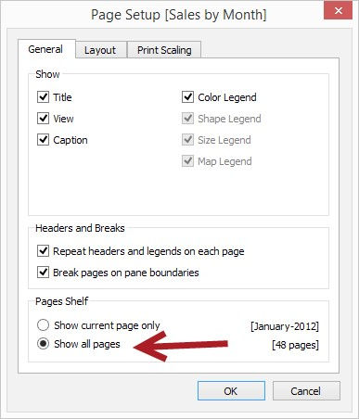

If this is not set, only the current page with the current value will be printed.

## Filters shelf

The Filters shelf hosts the data fields you want to use for narrowing down your data.

Depending on the type of field you're using as a filter, the filter options may differ. We still have to keep in mind here how discrete and continuous fields differ.

### Discrete Filters

When we drag a discrete field onto the Filters shelf, we will see the following options:

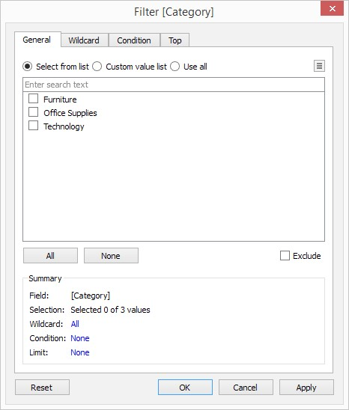

Because we are working with discrete fields, which have a finite number of values, we will be asked to choose which of the values to include or exclude. There are four tabs in this filter window:

* General shows a list of values to select from f Wildcard allows us to specify string patterns to match f Condition provides options to indicate rules or expressions for inclusion (for example,

SUM(Profit) > 0 f Top allows records to be limited by Top or Bottom based on some condition

In addition to dragging a discrete field into the Filters shelf, we can choose to surface the control and let the audience do the filtering themselves. We can simply show filter by rightclicking on a pill in the side bar or any of the cards or shelves and selecting Show Filter. If this field is not in the Filters shelf yet, then this field will be automatically placed there:

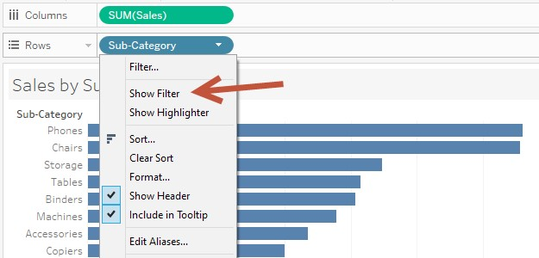

When you click on the right corner of the filter control, you will see additional options for a discrete filter, including the type of filter control (or mode):

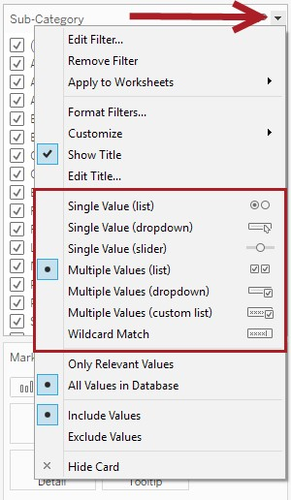

The different modes available for discrete filters are as follows:

* Single value (list) f Single value (dropdown) f Single value (slider) f Multiple values (list) f Multiple values (dropdown) f Multiple values (custom list) f Wildcard match

Filters can also be customized. We can change the title, the scope (that is, which worksheets will be affected), as well as choose to hide or remove certain options, such as showing the All option:

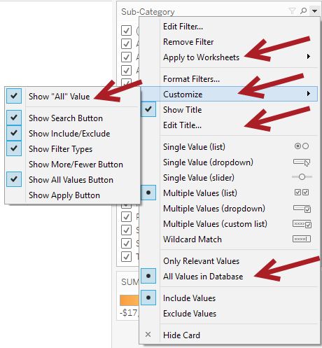

The appearance of filters can also be customized to match the appearance of the rest of the dashboard.

Learn more about Tableau Filters from Tableau's product online

documentation: [**http://bit.ly/tableau-filtering**](http://bit.ly/tableau-filtering)

### Continuous Filters

When we drag a continuous field onto the Filters shelf, we get a different set of options than discrete. We are first prompted to choose the type of data we want to filter on. We can choose to filter on each individual values, or on aggregated values, or even standard deviation or variance:

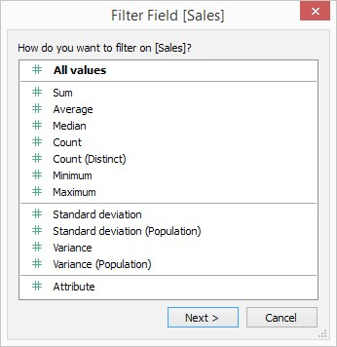

Once we select the type of value we want to filter by, we are presented with options that allow us to select ranges of values:

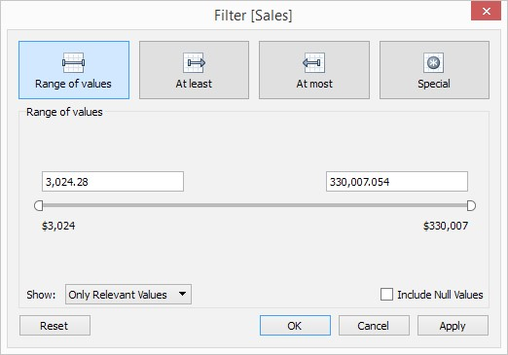

A continuous filter manifests itself as a slider. When we click on the dropdown on the top-right corner of the filter control, we will see options related to continuous values:

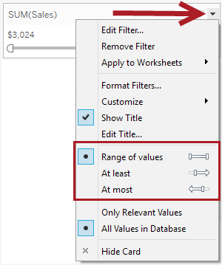

We can adjust the slider to allow for a range of values to be selected, or to provide either a lower boundary (for example, at least $1M) or upper boundary (at most $1M).

Learn more about Tableau Filters from Tableau's product online

documentation: [**http://bit.ly/tableau-filtering**](http://bit.ly/tableau-filtering)

### Date Filters

When a date field is placed in the Filters shelf, we will see options pertaining to how we can filter dates:

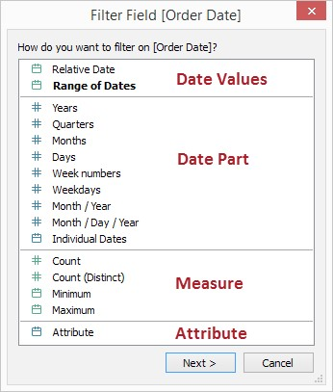

In this window, we can see that depending on the choice, we can either get a filter control that is discrete or continuous. If we choose Date Part or Attribute, which are fields that have blue icons beside them, we will get a control that allows us to choose individual values:

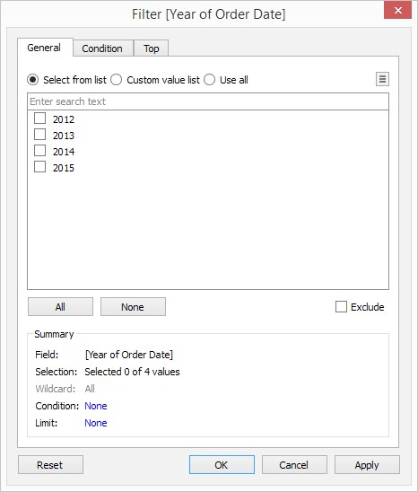

If we choose Date Values and Measure, which are fields that have green icons beside them, we will get a control that allows us to choose a range of dates:

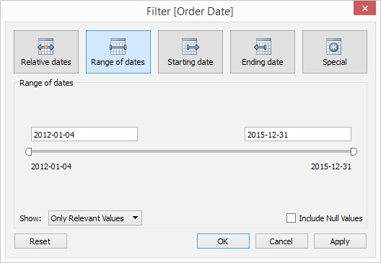

When we show control for date values, the control looks like a slider for a typical continuous field. However, when you select the value, you will see a calendar control that will allow you to more easily choose specific dates:

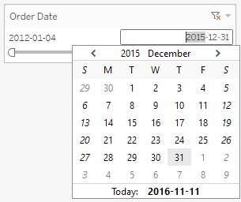

To show additional options for the filter, click on the drop-down arrow on the top-right corner of the filter control:

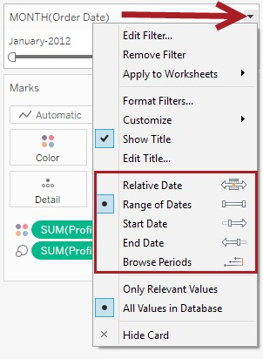

We can see that there are a few options, such as allowing relative dates or specifying start or end dates. With relative dates, additional options will be shown to allow the selection of date intervals:

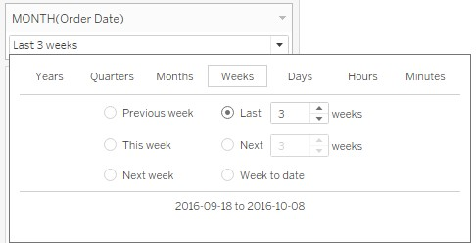

We also have an option to browse for periods. Very cool!

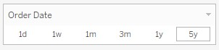

Tableau filters are quite flexible and can definitely add a lot of value to your charts and dashboards. The key is really just knowing and understanding which options are available.

Learn more about Tableau Filters from Tableau's product online

documentation: [**http://bit.ly/tableau-filtering**](http://bit.ly/tableau-filtering)

### Filter Scope

You can be more selective regarding the scope of the filter – specifying only the current worksheet to be affected, or specific worksheets, or all worksheets that use the same data source:

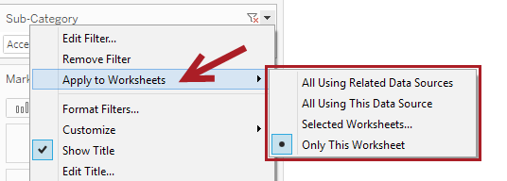

As of Tableau 10, we can also choose to have the filter affect multiple data sources.

## Show me

Show Me is the chart wizard that, by default, appears in the top-right corner of your worksheet design workspace:

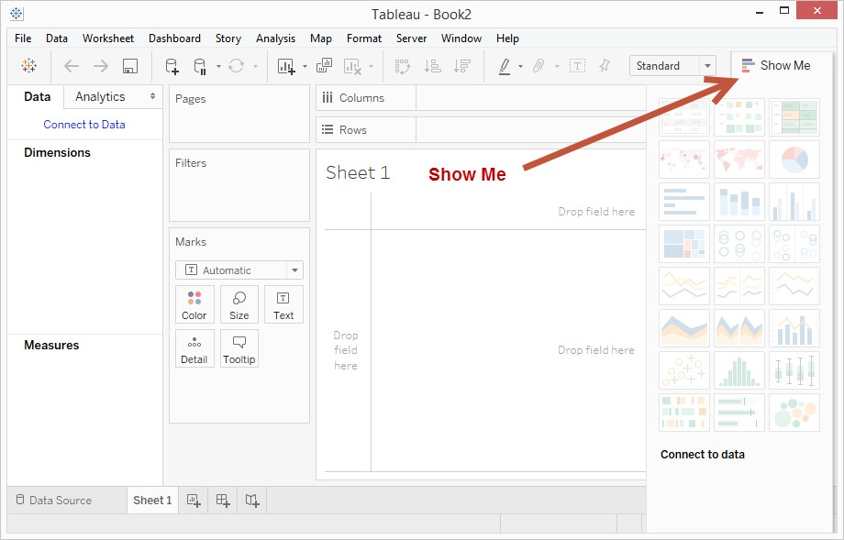

Clicking on the Show Me title will toggle between expanding and collapsing Show Me.

Show Me allows us to explore possibilities. When we select certain number of fields from the side bar, some chart icons in Show Me will become enabled, depending on which combination matches specific charts:

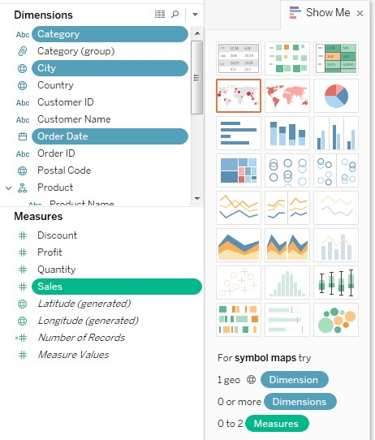

When we drag a field to the middle area where it says drag sheets here, Show Me is technically invoked. This means we are letting Tableau decide what it thinks is the best visualization for what we are dragging.

While this is a great tool, it is still good to get familiar with how to create the visualizations from scratch, or to know how to change what was automatically placed by Show Me so you can get the visualization you want.

## Annotations

Annotations help provide additional context or help draw attention to specific values or areas in your graph.

There are three kinds of annotation:

* Mark annotation is attached to a specific mark, and will follow this mark even when you change the layout of your view.
* Point annotation is attached to a specific point in your view. The point is an extrapolated value from one or two axes in your view. These axes are produced by your continuous pills.
* Area annotation is not attached to any mark or point, but is meant to provide description in a general area.

You can add an annotation by right-clicking on a mark (for mark annotation) or any area in your graph (for either the point or area annotation), and going to the Annotate option:

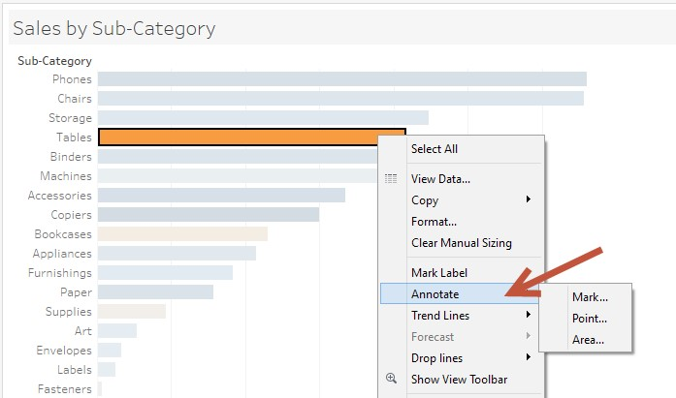

The actual annotation window is simply a text editor, similar to the text editors you see for

Label

or

Tooltip

:

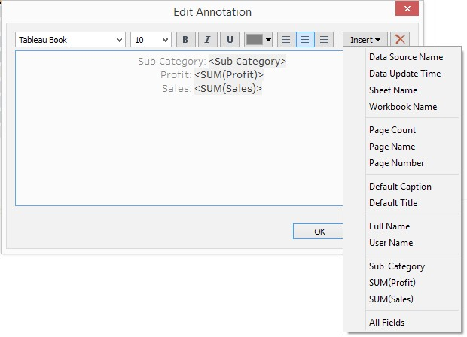

You can also take advantage of the Insert button within the annotation to insert values from fields used in the view, as well as some pre-defined fields in the workbook, such as Data Source Name or Data Update Time.

## Formatting

You can format the worksheet level components of your view when you go to the Format menu. You will see the different components that can be formatted in the options:

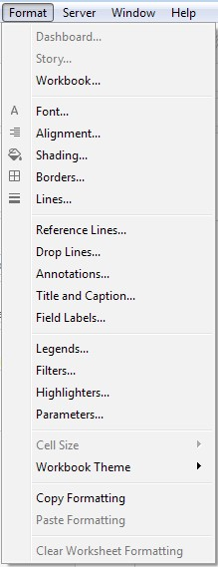

The capability to format at the workbook level is new in Tableau 10. This, however, currently allows you to modify the fonts globally:

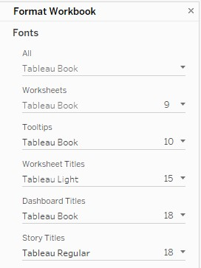

You may need to go to different places in the application to format specific items. For example, if you want to format a label, you have to click on the Label property in the Marks card. If you want to format an axis, you can right-click on the axis and select Format.

## Sorting

There are different ways to sort marks or headers in Tableau.

A quick sort is a quick way to sort by hovering over an axis or hovering over the column header until you see a sort icon. If clicking on the icon on an axis (produced by a green, continuous field), the first click sorts the measures in descending order. The second click sorts ascending, and the third click sorts it back based on data source order. If clicking on the icon on a column header (produced by a blue, discrete field), the first click sorts the headers alphabetically in ascending fashion, then descending, then back to data source order:

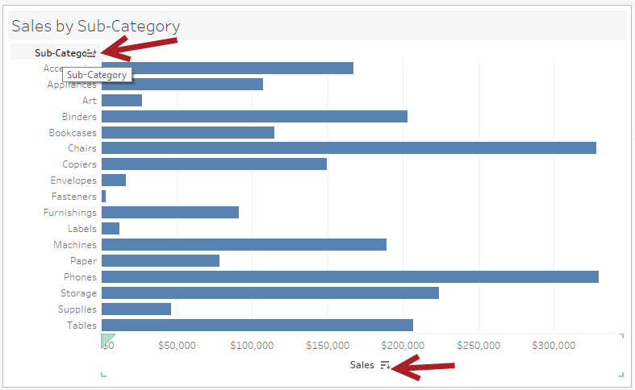

Tableau also supports manual sort, which can be done by dragging and dropping values manually.

The third type of sort is called computed sort, which is something that is configured when you right-click a discrete field. When you select Sort, additional options are made available, such as sort order and sort by. Under Sort by, we can specify the aggregation and field we want to be used as the sort settings:

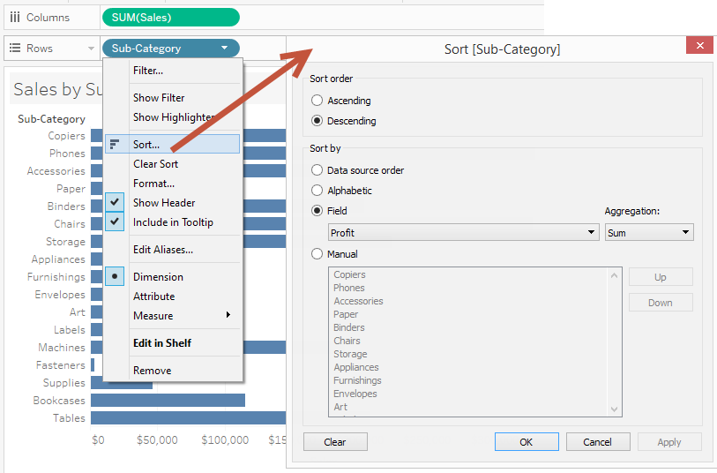

If you are sorting using fields that are not visible or obvious in the view, think again. Instead of clarity, this may create confusion. Take the following chart, for example.

Without any indication of how this is sorted, the chart may seem like it's just disorganized:

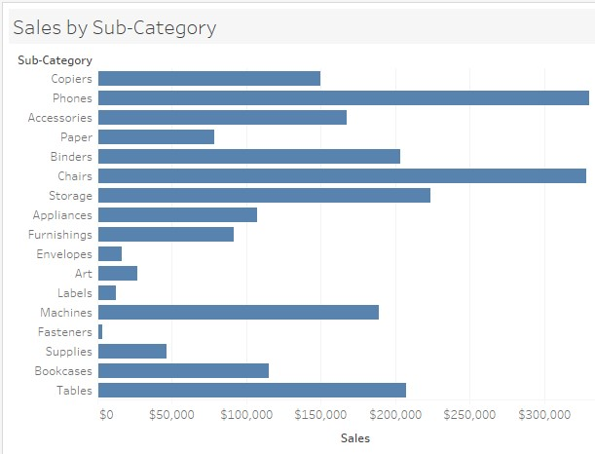

However, we can add some components that will make it easier for the audience to understand how it's sorted, such as a title or color, instead of letting the audience guess:

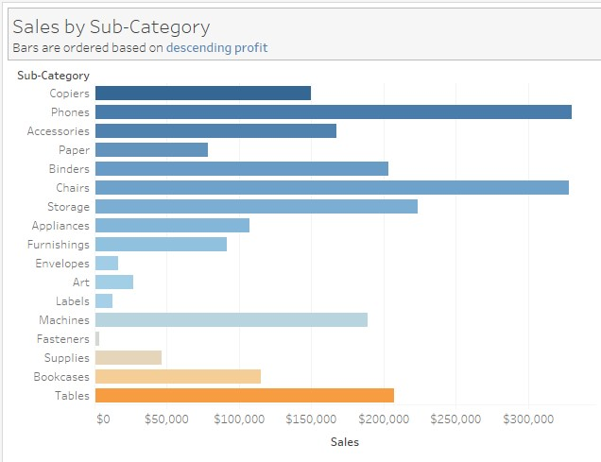

### Side bar – expanded

The side bar of the worksheet canvas has two tabs – Data and Analytics. The Data tab houses information from your data source. It contains a section for Data Sources, Dimensions, and Measures.

Tableau provides visual cues not only in the side bar but also for the rest of the interface. For example, each field in the side bar has an icon beside it that represent the data type (or item type). How many visual cues do you see in the side bar?

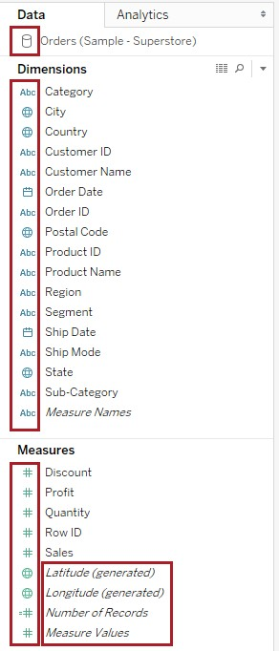

Some of these visual cues may be subtle, but they're there. If you haven't worked with the product for long, some are easy to miss. But once you get the hang of it, you will pay more attention to the visual cues (such as fonts, color, or icons) because they mean something, and they can help explain how these can affect your visualization.

A complete list of the Tableau visual cues and icons, and where you can find them, is documented on the following page: [**http://bit.ly/tableau-visualcues**](http://bit.ly/tableau-visualcues)

If you work with a data source (such as SQL Server or Oracle) that defines the data type,

Tableau will use those data types. However, if the data source does not have this definition, Tableau will assume a data type for each of the fields based on the first few records that it reads. If this is incorrect, you can simply drag the field to the correct group.

When you right-click on these fields, or when you click on the arrow that appears when you select the field, you will see additional options for the field. From this menu, you can change the data type if needed, create hierarchies, and change aliases and default properties. For example, if you always want the Sales field to have a currency symbol and reported in the millions, you can go this field's Default Properties and make the changes:

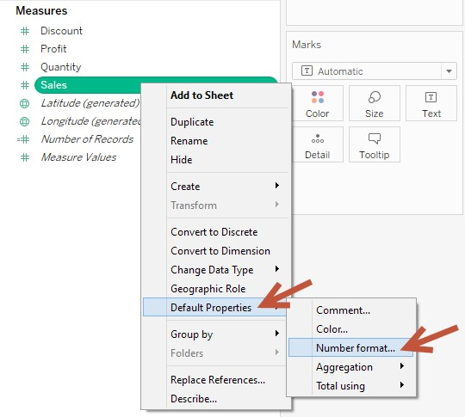

There can be additional sections on the Data side bar. There may be a Sets section and a Parameter section. These sections will only be visible when corresponding components are present:

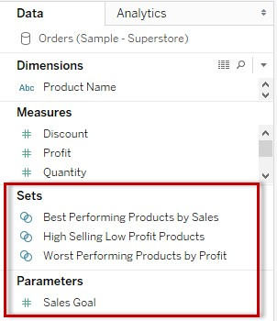

A great way to get acquainted with your data is by using the Describe option, which is available when you right-click your field (or click on the dropdown). Describe allows you to see the data type and remove columns and locale, as well as see some of the values present:

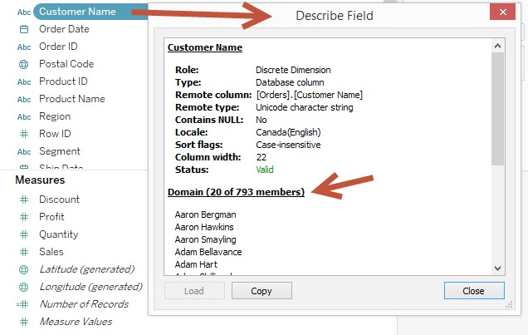

#### Underlying data

You do not have to go back to your data source to see your underlying data. Right beside the Dimensions section in your side bar, you can find a grid icon that allows you to launch the View Data window:

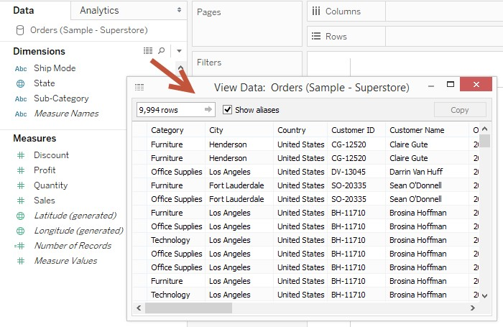

You can also view a subset of this underlying data when you select a mark from your view, and select the same grid icon:

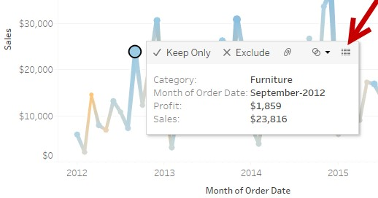

#### Grouping by folders

By default, data fields are shown in a flat structure by field name in alphabetical order. It is possible to organize these fields by folder. If you click on the dropdown beside the Dimensions section, you will find an option to Group by Folder instead of Group by Data Source Table:

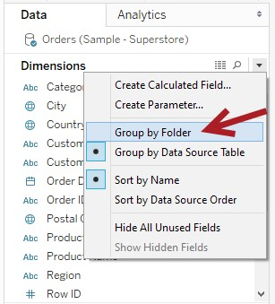

When Group by Folder is selected, the option to create folders will be enabled, which will then allow you to move fields to appropriate folders:

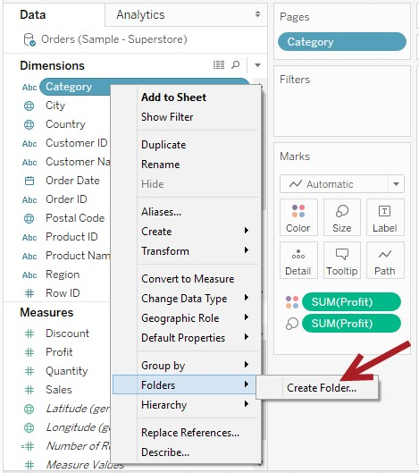

#### Dimensions vs Measures

When you connect your data source and go to the worksheet view, you will see that Tableau will have already automatically categorized your fields into two sections – Dimensions and Measures.

Measures are quantitative fields that you may want to analyze and aggregate, for example, the sum of sales, the average discount, and the count of members. Dimensions are categorical fields by which you want to analyze your measures. You can also think of your dimensions as the slicers and dicers of your data. You will find these two terms mentioned in many data warehousing books and other resources.

By default, dragging measures onto shelves aggregates the measures. The default can be changed by right-clicking the field on the side bar and using the Default Properties option, and selecting the new default aggregation. You can also change this on a worksheet scope by right-clicking the measure pill on the shelf and selecting the appropriate measure:

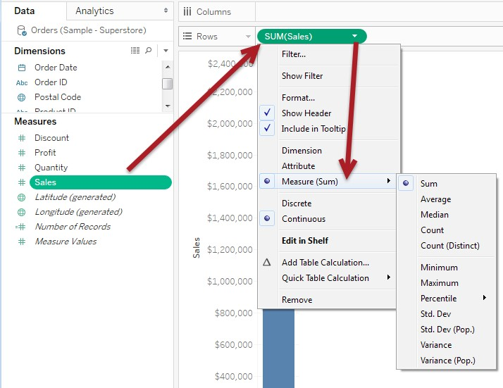

If a field has been incorrectly categorized as a measure and it was supposed to be a dimension, you can simply drag this field back to the Dimension section. Alternatively, you can right-click this field and choose Convert to Dimension. The same option exists when correcting a dimension that is supposed to be a measure:

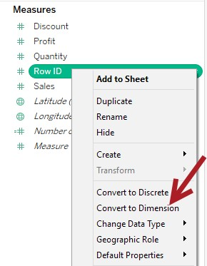

In the older versions of Tableau, anything that is numeric is automatically grouped in the

Measures section. However, this is not necessarily always true, especially in fields that contain ID values (such as Row ID, Line ID, Order Code, and so on). These fields are categorical, and while the values are numeric, they are really descriptors and are not meant to be treated as quantitative fields to be measured.

Tableau has since improved their field detection algorithms. For example, if an incoming field name has the words ID, Key or Code, this field will be identified as a Dimension. The same is true for any date parts that come in, even with abbreviated field names. A field called *Wk*, which represents *Week*, will be placed as a Dimension and not a Measure.

Tableau has also improved how fields are named after data connection. Fields coming in with underscores will be cleaned and made more readable. A field called *COUNTRY_NAME* in the data source will come in as *Country Name*, in the correct case and with the underscore removed.

Learn more about the field detection and naming improvements in Tableau

here: [**http://bit.ly/tableau-field-detection-improvements**](http://bit.ly/tableau-field-detection-improvements)

#### Blue(Discrete) vs Green (Continuous)

The color of the fields (or pills) in Tableau play a significant part in how Tableau will use the field in the view. You will see these colors in the data type icons beside the fields in the side bar, as well as the pills that have been placed in the shelves.

Here is a quick rundown of the differences between blue and green:

|  |  |  |
| --- | --- | --- |
|  | Blue | Green |
| Type | Discrete | Continuous |
| Definition | Individual, finite, countable values | A range of values; a continuum |
| Displayed as | Header | Axis |

To better illustrate the difference, let's see these two in action. In the following screenshot, we dragged Sales, which is a measure and is by default continuous (green), onto the Rows shelf. A vertical axis is created with a range of 0 to the value of the total sales. From a visual perspective, we see a continuous range without any gaps:

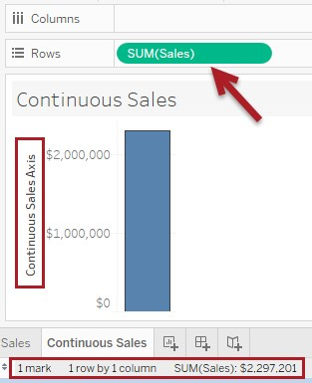

If, for example, we convert sales to a blue, discrete field and drag it to Rows, we will no longer see the axis. What we will see is a series of values that correspond to each Sales value from our data source. These are countable values. In fact, you will see the exact number of values in the status bar – 6,144 discrete, individual sales values:

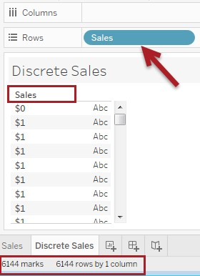

A common misconception about blue and green (or discrete and continuous) is that blue will always be under Dimensions and green always under Measures. This is not the case. It is possible to have a green, continuous, numeric field in Dimensions, and blue, discrete, nonnumeric field in Measures, as can be seen in the following screenshot:

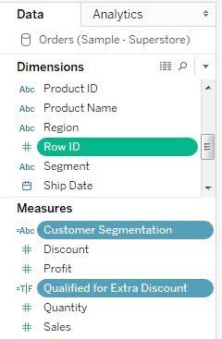

#### Measure names and Measure values

Measures are quantitative values we want to analyze. Measures are further broken down into a label-value pair Tableau calls Measure names and Measure values:

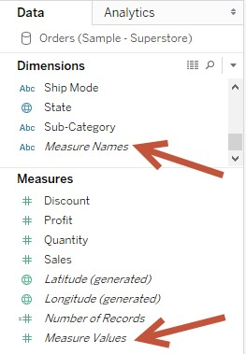

Measure names are the actual names or labels for the measure, and are considered discrete. Measure values are the actual numbers for their corresponding labels, and are considered continuous:

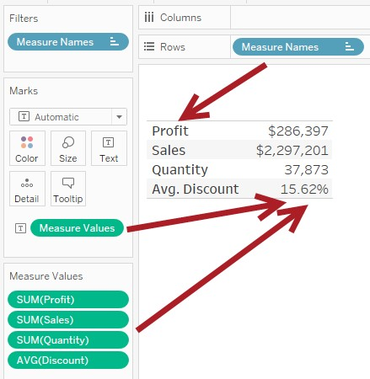

Measure names and values are often associated with graphs that require a group of measures to share the same space or mark, for example, in text tables, where you need to use the Text property in the Marks card for multiple measures, as seen in the preceding screenshot.

### Using Custom Shapes

Tableau supports a mark type called Shapes. By default, Tableau already provides a number of shapes that can be used. If we want to expand this selection, we can add our own custom shapes that can be used when the Shape mark type is selected.

To do this, we have to add the images in the Shapes folder in the My Tableau Repository folder. It is best to add the new icons to a different folder than the ones that came with Tableau, for easy identification:

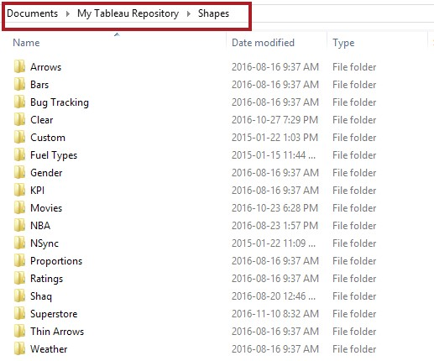

If you added the folder while Tableau is open, you will need to Reload Shapes:

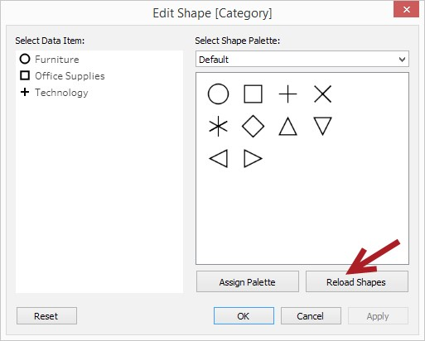

Otherwise, the new set of shapes should be available the next time you open Tableau:

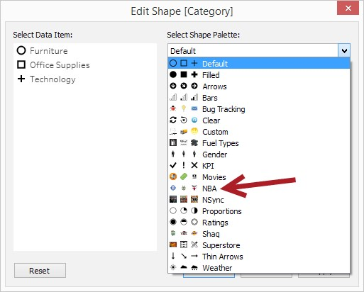

Check out the *Using Path to Display Movement on a Map* recipe in *Chapter 5*, *Maps and Geospatial Visualization* to get hands-on practice of utilizing custom shapes.

### Working with geographic data and maps

When you install Tableau, a local geocoding database is also installed locally in your system. This is why Tableau can easily map your location data. If the geographic data comes in with a standard, recognizable column name, you will be able to use maps in your visualization. You will also see the Latitude (generated) and Longitude (generated) fields added under Measures:

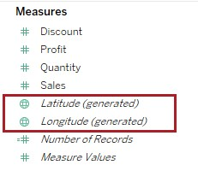

By default, you will need Internet connection to render maps. Because the default maps in Tableau are fully interactive and allow you to zoom in and out, it needs the Internet connection to fetch the appropriate map tiles (or map background images) based on the zoom level you have selected. If you ever need to present anything with maps and do not have an Internet connection, you can choose Offline mode, which can be found in the Map menu option. Note, though, that because this relies on only map tile images that are installed with Tableau, you may not be able to see as much detail (or none at all), depending on the zoom level:

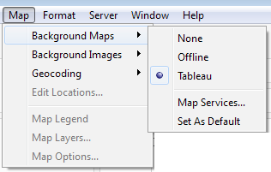

You can adjust the geographic role of any of your fields, in case Tableau is not able to accurately assign the correct one. When you right-click on any of your fields (or click on the drop-down arrow of the pill), you will see an option for Geographic Role:

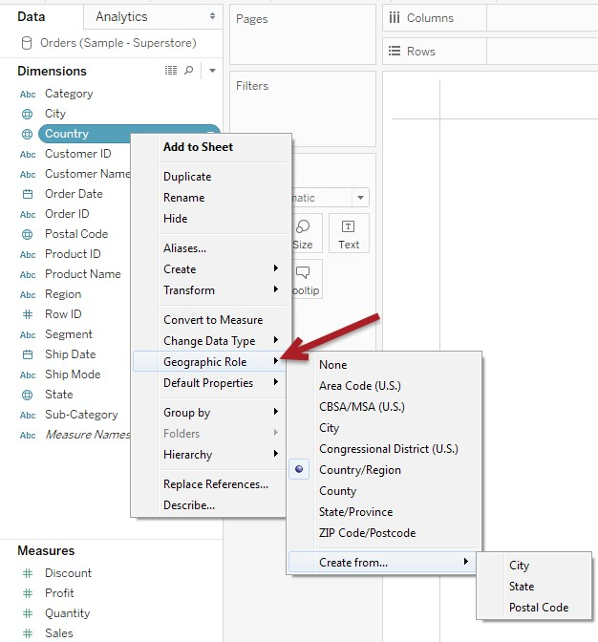

Even if the locations you want to map are not recognized by Tableau, there are still multiple alternatives: f You can connect to another data source that has the geolocation information (at least the name, latitude, and longitude) and either blend or join this back to your original data source f You can import custom geocoding into Tableau

You can also change what your map looks like. You can use any of the following to change the look and feel of your maps:

* Other Tableau map styles (Light, Normal, or Dark)
* Mapbox maps f Web Mapping Service (WMS) f Custom background image

Tableau also promises to support connection to shape (.shp) in a future version.

### Working with dates

Dates are special because they have natural hierarchies, and they can either be discrete or continuous.

When you drag a date or date time field onto a shelf, by default, this gets rolled up to the YEAR level and is presented as a discrete field. There will be a plus sign in the discrete date field that allows you to drill down on the date.

When you click on the drop-down arrow on the date pill, you will see additional options are available:

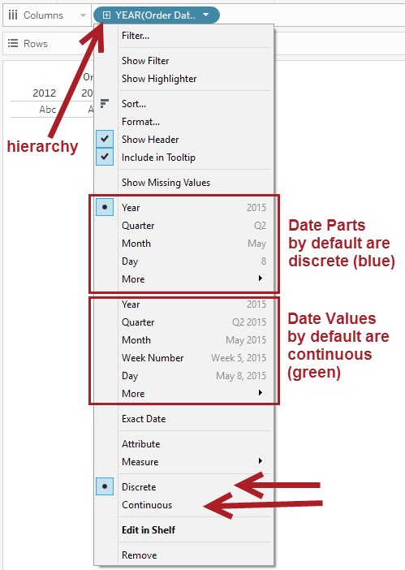

There is a section called Date Parts, as shown in the screenshot, that allows you to change the pill to specific parts of the date. For example, you may just want to show months regardless of the year associated with it. Date Parts are also discrete by default, but can be converted to continuous.

The section that follows the Date Parts is the Date Values section, which uses different levels of detail for dates that are always with respect to time. Date Values are continuous by default, hence producing an axis in your canvas.

Dates also have an extra setting for Fiscal Year under Default Properties. This feature is useful for companies with consistent, clear-cut fiscal years that start on the first of the month.

However, for companies that have more variable fiscal years, this feature won't be appropriate:

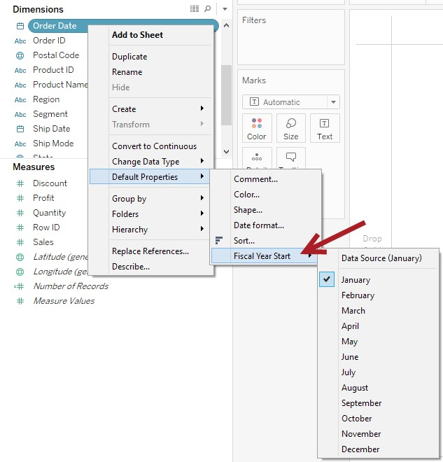

We can also create custom dates by right-clicking on the date field, selecting Create, and then

Custom Date

:

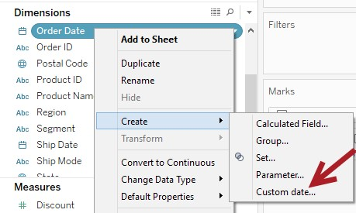

This allows us to be more specific about what kind of date we may want to use. This also allows us to suppress the natural hierarchy of dates if we don't want to expose the capability to roll up or drill down:



In the Create Custom Date window, there are two radio buttons – one for Date Part, and another for Date Value. Date Part extracts a part of the date (for example, Month, regardless of year) is by default discrete, which produces a header. Date Value is still a full date relative to time, and is by default continuous, which produces an axis.

Currently promised in a future minor release is the capability to roll up for continuous dates. Currently, we can only drill down with continuous dates, but cannot roll back up.

### Groups vs Sets

Tableau defines groups as "combination of dimension members that make higher level categories", and sets as "custom fields that define a subset of data based on some conditions".

While these two definitions sound similar, groups and sets are very distinct. Groups are great for creating combined labels for different members and aggregating those members' individual measure values. Groups are also great for grouping together similar items – whether it's for organization (little box, big box, and medium box can all be called box) or data correction (Bangladsh, Bangledesh, and Bangaldesh should all be Bangladesh).

We can create groups from our view by selecting a number of headers and clicking on the paper clip icon:

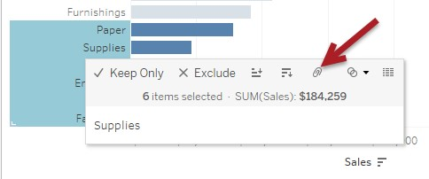

We can also create groups from the side bar, by right-clicking on a specific field and selecting Create and then Group.

When a group is created, you will find another data field in your side bar with a paper clip icon beside it. To modify groups, we can simply right-click this field and select Edit Group:

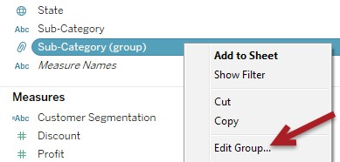

Sets are pretty distinct because sets can be dynamic. You may decide to create set based on the top 10 sales items. The members in this set may migrate in and out of the set depending on what their sales rank is at different periods of time.

We can create sets by selecting marks from our view and choosing the Venn Diagram icon that appears in the tooltip command bar:

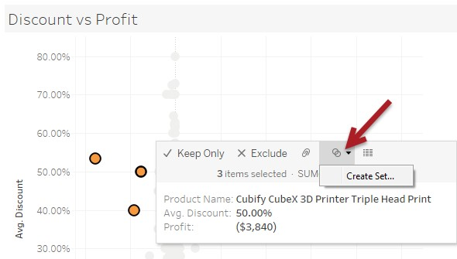

We can also right-click on a field in the side bar and selecting Create and then Set:

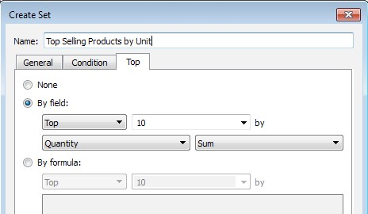

We can perform operations on sets and compare them, unlike groups. When you select two sets and right-click, you will see an option to Create Combined Set:

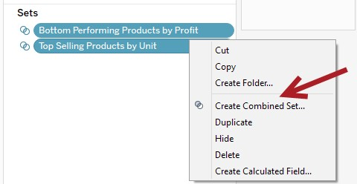

A window with additional options will appear. You can choose to combine all members of the set, or only choose members that exist in both, or members that exist in one but not the other:

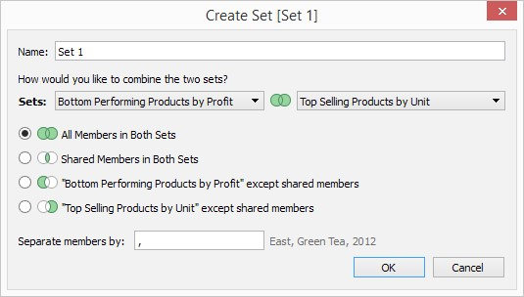

It is important to remember that both groups and sets need similar items. They must all come from the same domain. Groups can be created for both dimensions and measures, while sets can only be created on measures.

### Data highlighter

The data highlighter is a new feature in Tableau 10 which is very similar to what the color legend does with the highlighting, but uses a search box with a lot more responsiveness. As you hover over the potential matches, the view will automatically highlight those points and dim everything else that doesn't belong to the highlighted group. This feature is used in a number of recipes in this book, so you are very likely to encounter it soon, if you haven't already.

#### Analytics tab

The second tab that you will find in your side bar is the Analytics tab. This tab hosts some quick options to summarize data (constant line, average, median, box plot, and totals), or to add a little bit more insight (lines with confidence intervals, trend lines, forecast, and clusters):

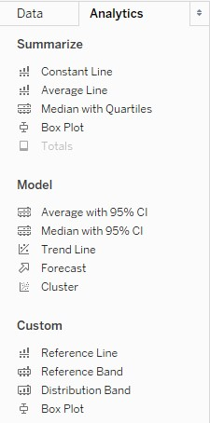

You can simply drag these options onto your view, and depending on how your view is laid out, you may be asked for the scope. For example, you may be asked if you want a reference line to be applied to individual cells, per pane, or to the whole table:

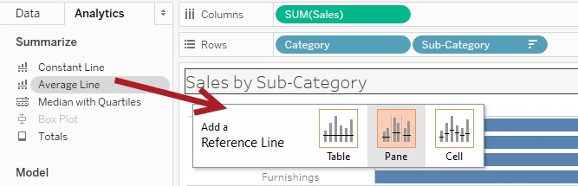

While the Analytics side bar allows us quickly add these lines using a simple drag to the view, many of these options can also be accessed either by right-clicking on axes, or going to the Analysis menu. Chances are, you will need to use these alternate methods anyway to further edit the lines/cluster/forecast, or to remove them:

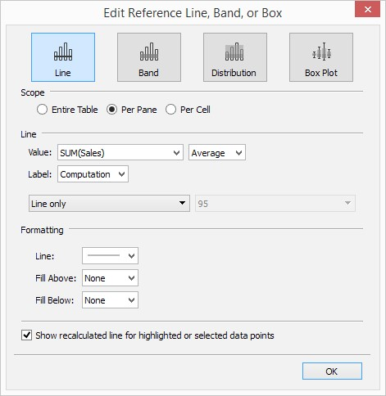

From this window, we can see that there are different types of reference items. There is a reference line, a reference band, reference distribution, or a box plot. For each of these reference items, we can identify the scope. The scope identifies the extent of values to be used with the reference line:

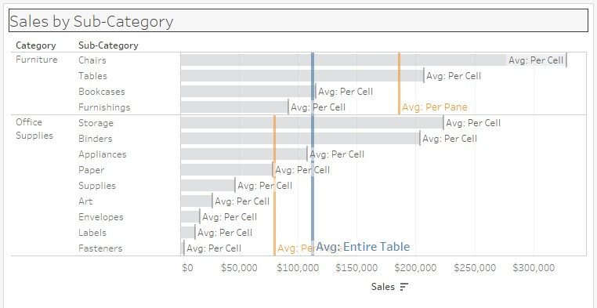

Tableau also supports connecting to statistical files such as R, SPSS, and SAS. This allows you to leverage the computing and statistical strengths of these software packages as well as take advantage of Tableau's visualization features:

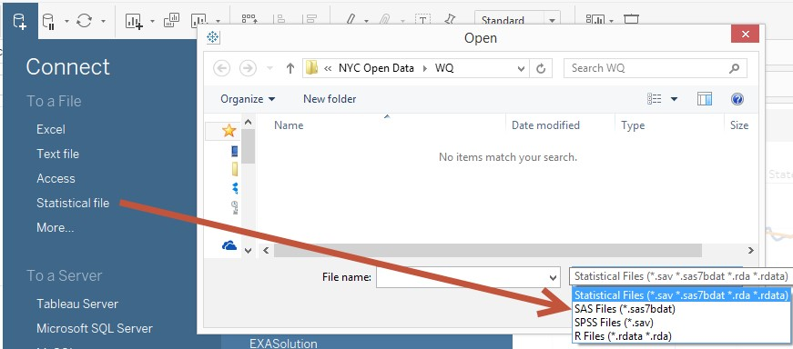

As of Tableau 8, Tableau also supports R expressions from within calculated fields.

*Chapter 6*, *Analytics*, is a full chapter that discusses many of the different options in the Analytics side bar.

#### Dashboard

The dashboard is where you can combine multiple sheets to present your data and analysis in a more cohesive fashion. Dashboards don't have to be busy. You don't have to have multiple sheets every time. It can also be effective to minimize what's in the dashboard to highlight content and important pieces.

This is what you will find on the side bar of a dashboard:

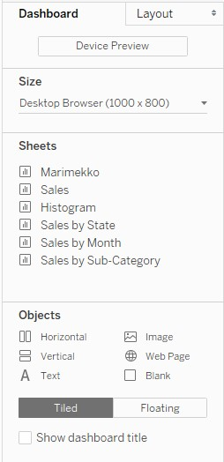

We can adjust the size of the dashboard to specific dimensions, or we could also leave it as Automatic, which means Tableau will automatically adjust the dashboard based on the resolution of the device that is viewing it:

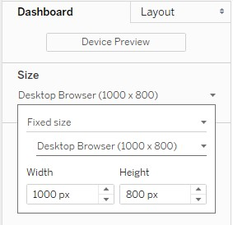

When sizing dashboards, we do want to cater to the majority. If the majority of your expected consumers are using desktops, we want to cater to the resolution of those desktop machines. There may be times, though, that you need to create multiple versions of your dashboard because of the sizing requirements.

All the sheets in your workbook will show up under Sheets. When you hover over the sheets, a small thumbnail will appear that shows you want that sheet looks like. This is extremely helpful (and a welcome addition in Tableau 9), especially when working with many views:

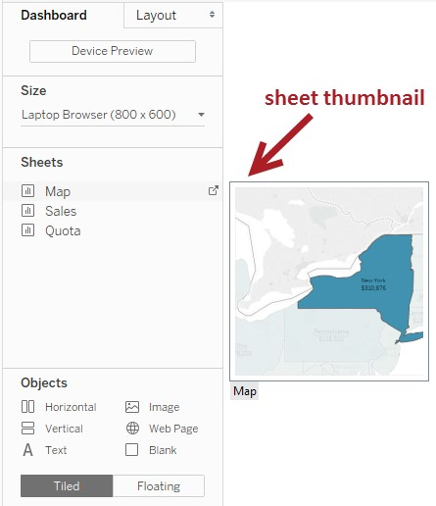

In addition to worksheets, there are a few more items that can be placed in dashboards. In the Objects section, you can see six items – Horizontal (Layout Container), Vertical (Layout Container), Text, Image, Web Page, and Blank.

* The layout containers allow you to group different components and move or organize them as a group
* Text can be used to add context, history, instructions, and the like to your dashboards f Images are great, especially for branding, adding graphic items such as a logo, or simply enhancing the look and feel of your dashboards
* Web Page embeds a web page in the dashboard, and can also be the target of

URL actions f Blank is an empty space that can be used to add spaces in your dashboard where they may feel cluttered, or could simply hold space for floating items

These six may not look like a lot, but you might be surprised at the flexibility and possibilities these options can give you.

Items can be placed either as Tiled or Floating items.

Tiled means Tableau will place the objects automatically in a grid, and all of the items in the grid take up 100% of the space. Tableau ultimately controls the dimensions of tiled items, and all we can do is adjust the dimensions by dragging the borders:

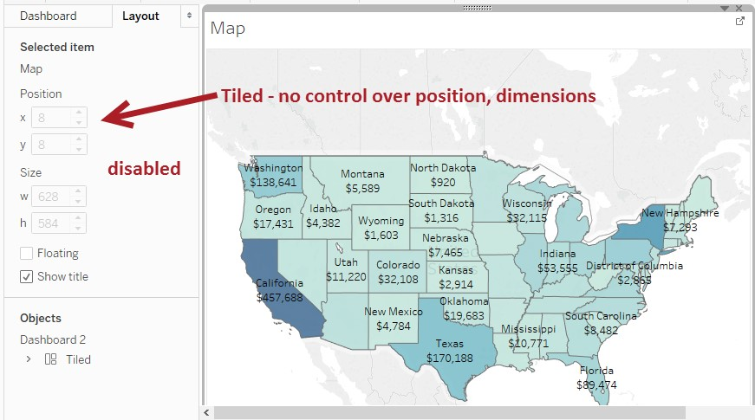

Floating allows items to be placed on top of items in the grid. Floating items can be controlled more granularly—from the *x* and *y* positions, to the width and the height:

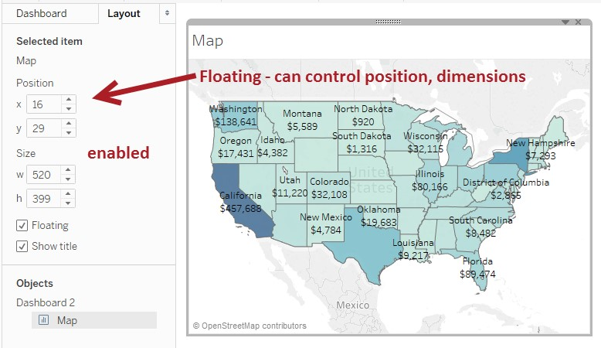

The Device Designer is new in Tableau 10. It allows you to preview what your dashboard might look like on different devices:

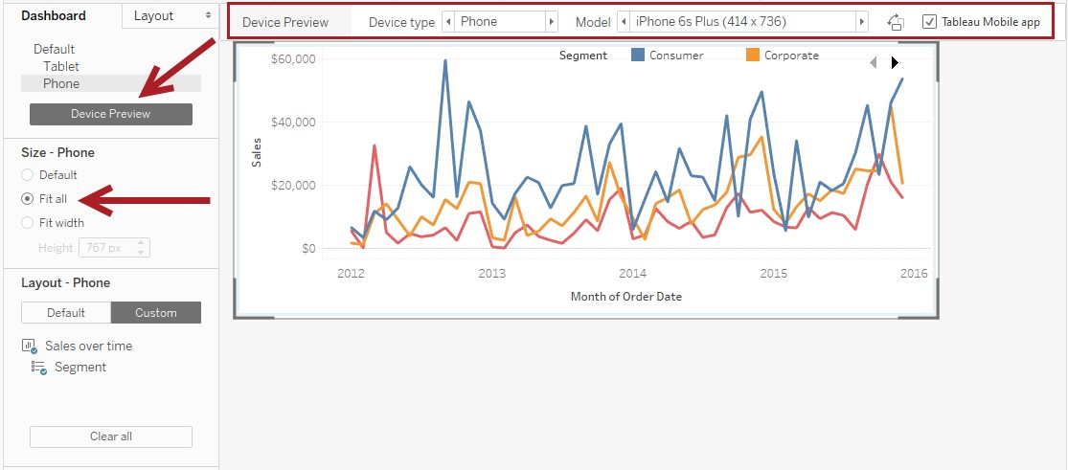

This feature not only shows how your dashboard would look, but it also allows you to change the appearance of your dashboard on different devices without needing to create different dashboards. You simply need to add the device in your layout, and as the specific device is selected, make your changes:

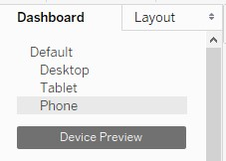

The original dashboard does not get affected, but the views on different devices are now adjusted. This is awesome!

Interactivity in dashboards can be achieved using Actions:

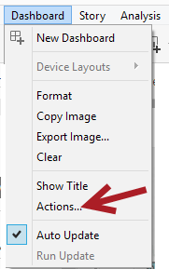

When you select Actions, a new window opens. Here, we can add the specific actions we want to incorporate in our dashboards:

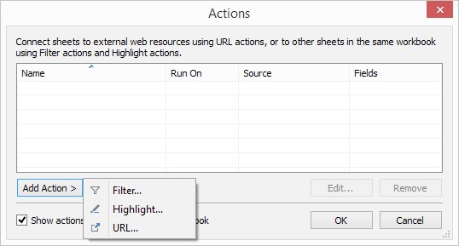

Tableau supports three types of action: Filter, Highlight, and URL, which are described in the following table:

|  |  |
| --- | --- |
| Action | Description |
| Filter | Allows you to send data, and filter (or narrow down) data between worksheets or dashboards |
| Highlight | Allows you to visually emphasize a specific set of data by highlighting marks that have common values, and dimming marks that do not |
| URL | Allows you to call up a web page, or file, or other web-based resources via a URL.  If you have a Web Page component, the web page appears in that component.  Otherwise, this opens up in the default browser window. |

Let's take a look at the settings for Filter actions in the following screenshot:

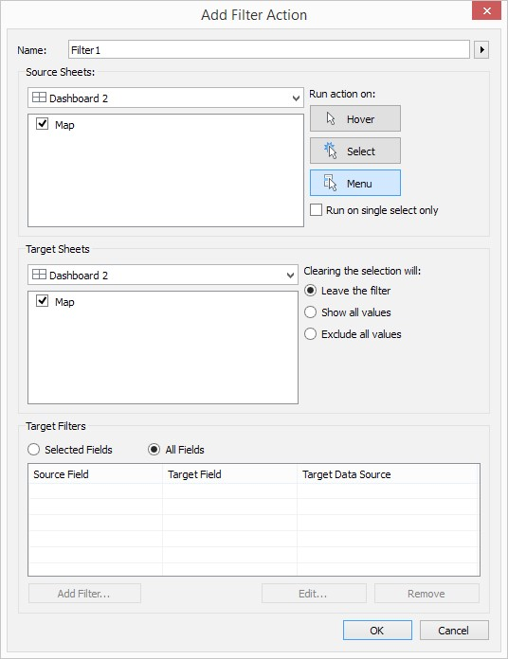

These are the main settings in a filter action:

|  |  |
| --- | --- |
| Setting | Description |
| Name | Identifier for the filter. If this filter action runs on Menu, this will appear as a hyperlink. |
| Source Sheets | Sheets that will be tied to specific actions. |
| Target Sheets | Sheets that will be affected by the actions done on the source sheets. |
| Target Filters | Fields that will be used to narrow down data in target sheets. By default, this uses all fields that are common. |
| Run Action On | Choices for which movement will trigger the action. Actions can be run on the following:   * Hover f Select * Menu   For the Menu option, the filter action name will appear as a hyperlink after the mark is clicked. |
| Clearing the selection will | Specifies what will happen if the selection is cleared. The target sheets could either retain the existing filter, show all values, or remove all values. If we choose to Exclude all values, the area taken up by the target sheets, by default, will appear empty. |

Actions are covered in more detail in *Chapter 4, Dashboards and Story Points*.

#### Story

Stories can be created to supplement or enhance presentations. Instead of exporting Tableau views and dashboards into static images and then using them in other presentation packages, stories allow you to capture and organize your main points all from within Tableau. Because you are still within Tableau, you still get all the interactivity features of Tableau.

You can create a story by clicking on the New Story quick icon (the one that looks like a book) at the bottom, or from the Story menu at the top. Inside the Story canvas, you can use any existing worksheet or dashboard as a Story Point. Each point will have a caption area that provides a brief description:

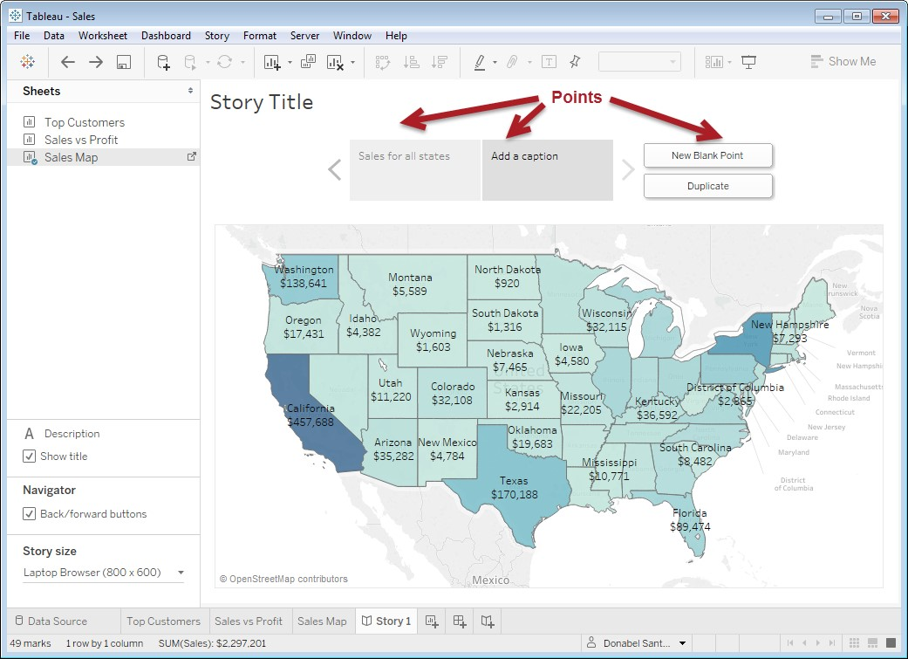

If you make any changes to any existing worksheet or dashboard already included in your Point, you are given the option to update the current point, or to create another copy of the point with the modifications in it:

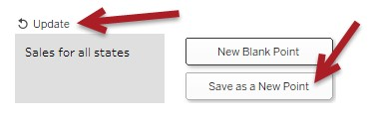

Story Points can definitely help create more powerful, engaging presentations. You can find out more about Story Points in *Chapter 4*, *Dashboards and Story Points*.

#### Summary of Filters

Here is a quick summary of the different types of filter supported in Tableau.

Extract filters are filters applied to extracts, and allow the rollup and hiding of unused fields.

Data source filters apply to the data source so that information not needed does not flow into Tableau.

Dimension and measure filters are filters based on dimension and measure fields. These are discussed more extensively in an earlier section, called *Filters shelf*. These filters each connect to the data source, and act independently of each other, hence exhibiting the AND behavior, that is, all the conditions must be true.

Context filters are filters that other dimension and measure filters filter against. When context filters are present, dimension and measure filters no longer connect directly to the data source. Instead, they filter against the results of a context filter.

We can add context filters by right-clicking on a pill in the Filters shelf and choosing Add to Context:

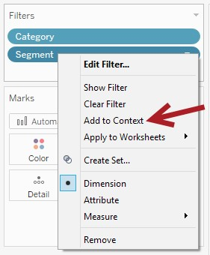

Once a field is added to context, the appearance changes. The color of the pill changes from blue to gray:

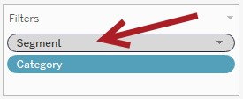

Context filters are often used to get filtered *Top N* records.

In past versions, context filters were implemented as temp tables and were always touted as performance boosters. In the most recent version of Tableau, this is no longer the case, as documented by Alan Elridge from Tableau Software in his white paper *Best Practices for Designing Efficient Tableau Workbooks*, which can be found in **http://bit.ly/tableauefficient-workbooks**. Context filters no longer create temporary tables, although they are still used to force filter precedence.

Quoting the Tableau online documentation found in **http://bit.ly/tableaufiltering**, there is a specific order filters are executed and recognized. Filters are applied in the following order:

* Extract filters f Data source filters f Context filters f Dimension filters f Measure filters

This is just part of the story, however. It is important to note where other operations or fields fit in this equation to fully understand how Tableau would behave. For example, FIXED Level of Detail (LOD) expressions will execute after context filters, and therefore will not recognize dimension or measure filters. INCLUDE/EXCLUDE LOD expressions happen after dimension filters, but will not be affected by measure filters:

* Extract filters f Data Source filters f Context filters f FIXED LOD expressions f Dimension filters
* INCLUDE/EXCLUDE LOD expressions f Measure filters

A more in-depth discussion on Tableau's order of operations is presented in Appendix B, Calculated Fields Primer. This topic is also discussed in Tableau's online documentation in **http://bit.ly/tableau-orderofoperations**

**What's new in Tableau 10?**

Every version of Tableau adds exciting new features and enhancements that sometimes get data geeks (such as me) into a frenzy.

Tableau 10 is no different. Tableau 10 also did an overhaul with the user interface, so it looks a little bit different from the previous versions.

Here is a partial list of additions or improvements in Tableau Desktop 10:

f New font f Format workbook f Data highlighter f Cross data source filter f Cross database join f Clustering f Custom Territories f Data Highlighter f Variable-width charts f Device Designer

If you want to learn more about these features, many of them have been included or showcased in the recipes in this book. The complete list of new features can be found on the Tableau website, **http://www.tableau.com/new-features/10.0**.

And while we are talking about Tableau 10, Tableau is already planning the next version. Tableau keeps an active page on features that are coming up in the next minor and major versions. You can access the page at **http://www.tableau.com/coming-soon**.

As an aside, I am still waiting for the *viz-in-a-viz* capability (that was demonstrated in TC15), which allows sheets to be inserted in the tooltip. How cool is that?

**I've read the primer. What's next?**

This is just the beginning. We've barely touched the possibilities that Tableau opens up for us data geeks. I have some final pointers to share that I hope you will find useful.

#### I want to share my workbook

So far this book has only talked about how to create and design workbooks. This book does not cover how to share your workbooks.

There are a few ways to share, and the choice depends on what is available at your discretion and what your needs are.

If you want to share your workbook by sending or sharing your workbook files, you can use Tableau Reader. Tableau Reader is a free application that can be installed on someone's local computer. This will open up any Tableau workbooks and maintain interactivity.

If you want to share your workbook online and are allowed to potentially share or make your data public, you can use Tableau Public. You will need to have a Tableau Public account before you can publish to it. Workbooks published to Tableau Public need to use file-based data sources, or need to use extracts. As an author, you have some degree of control over which worksheets are available and if the workbook can be download.

If you are looking for an enterprise solution because you require people from your organization to be authenticated, you could go with either Tableau Online or Tableau Server. Tableau Online is Tableau's cloud hosting subscription-based service. Tableau will maintain the infrastructure, but you will have control over your assigned sites. If you cannot use Tableau's cloud services, or if you prefer to have your own server that you control, you can go with Tableau Server. With Tableau Server, the control is entirely yours, but the infrastructure and upgrades is your responsibility to maintain too.

**Is there a checklist for learning more about Tableau?**

While there are no official checklists, there is a starter kit that is posted in the Tableau Blog Series: Make Me Smarter. The starter kit can be found here:

**http://bit.ly/tableau-starter-kit**

Currently, the starter kit shows you some of the typical things that new folks try to get them up to speed with Tableau. Here is a screenshot of the current checklist:

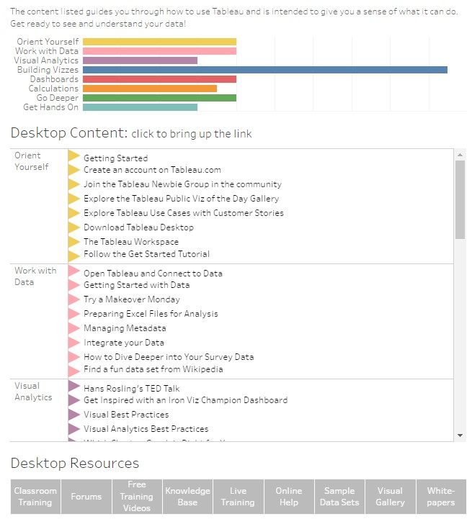

#### I don't know which type of chart to use

That's a great dilemma. It means you are thinking of making your visualizations more effective, instead of relying on just one or two types of graphs all the time.

There is no exact science when it comes to selecting charts, but there are guidelines that we can refer to. Ultimately, we have to understand the following points: f Your audience—you have to cater to their needs and understand how to best communicate with them. f Your data—you need to know your data and understand its context, the available dimensions and measures, and what is possible. f Your intent—what is your goal? What do you want to communicate, and what do you want your audience to do think/do after you present them with your data and findings?

Here are a few good resources to help you decide what kinds of charts might be appropriate with your data. Just remember these are only suggestions.

The most effective chart is still one that conveys the message to your audience and helps with your goal:

* Chart Chooser – A Thought Starter by Extreme Presentation (**http://bit.ly/ chart-chooser-thought-starter**)
* Designing Effective Tables and Graphs by Stephen Few **(http://bit.ly/ stephenfew-effectivechart**)

I have also quite enjoyed, and highly recommend, the following books:

f The Functional Art by Alberto Cairo f The Truthful Art by Alberto Cairo f Good Charts: The HBR Guide to Making Smarter, More Persuasive Data Visualizations by Scott Berinato f Data Visualisation: A Handbook for Data Driven Design by Andy Kirk

While these books do not provide an if-then-else guide to selecting charts, the books offer so much more about understanding why we visualize, what is important, what works, what doesn't, what's good, what's misleading, and so on. It also encourages you to think outside the box by looking at so many different examples and experiencing yourself how much clearer information is if presented in different ways.

#### I am having trouble doing <this>

While Tableau is a great tool—and might even be made of unicorns and pixie dust – we will still find challenges while working with it. The good news is that help is most likely just around the corner.

The Tableau support community is huge, and tightly knit. Many folks have used Tableau for years, and some have grown with the product. Many of them may have answered similar questions in the Tableau forums **(https://community.tableau.com/community/ forums**), or posted articles that explain solutions or alternatives.

If you want more direct answers, you can also file a support ticket with Tableau.

## I want to learn more

You can check this one off. You are already holding this book, right?

Kidding aside, Tableau is growing to be a wildly popular product. There are a lot of learning tools available from the Tableau website – on demand videos, live webinars, white papers, blog posts. If you prefer in-class learning, Tableau also offers classroom-based workshops from basic to advanced Desktop and Server.

There are numerous blog posts on how to use Tableau, tips and tricks that will make you gasp *you-did-what-with-Tableau?!*. I have listed some resources in Appendix C, but this list is by no means an exhaustive list of great websites and blog posts on Tableau.

One of the best ways to learn about Tableau is to see what other people do, and whenever possible, try to do those yourself. The Tableau Public Gallery (**https://public.tableau. com/en-us/s/gallery**) has a great collection of workbooks posted by authors around the world. I can bet you will surf this site for hours and not sleep (oh wait, maybe that's just me). Apart from the visualizations, the data stories are interesting and quite fascinating. If the original author has allowed you to download the workbooks, you can open the workbooks up in your desktop and learn how they have created theirs.

### I want to connect to other data geeks

I am glad you asked. There are many ways to connect. The Tableau Community site (including the forums and Tableau Public gallery), Twitter, Facebook, LinkedIn are great platforms even for professional networking. You can also attend a local Tableau user group meeting. A list of the Tableau user groups can be found at **https://community.tableau.com/ community/groups**.

If you have the opportunity to attend a Tableau conference, that's one of the best ways to connect and network with other data geeks. To learn more about the Tableau Conference, you can use the URL **https://tc<yy>.tableau.com/**—just replace the **<yy>** with the year of the conference. For example, the 2016 Tableau Customer Conference will be at **http://tc16.tableau.com**. Be warned—it's the biggest data party of the year, so you might, just might, have (lots of) fun.

Be sure to connect with the ultimate Tableau data geeks, the Tableau Zen Masters!

(**http://www.tableau.com/ZenMasters**)

# Conclusion

This document serves as a Tableau primer and should provide you a starting point if you are new to Tableau. While we tried to cover a breadth of topics, there is so more to Tableau than just this chapter. This is just the tip of the iceberg—there is so much more we do Tableau.

